BRIEFING NOTE: Protection Mainstreaming/ Safe & Dignified Programming
What is protection mainstreaming?
Protection mainstreaming is the process of incorporating protection principles and promoting meaningful access, safety and dignity in humanitarian aid. The guiding principles that must be taken into account in all humanitarian activities are:
- Prioritise safety and dignity and avoid causing harm: prevent and minimise as much as possible any unintended negative effects of your intervention which can increase people's vulnerability to physical and psychosocial risks.
- Equality/meaningful access: arrange for people’s access to impartial assistance and services - in proportion to need and without any barriers (i.e. discrimination). Pay special attention to individuals and groups who may be particularly vulnerable or have difficulty accessing assistance and services.
- Accountability to beneficiaries: set-up appropriate mechanisms through which affected populations can measure the adequacy of interventions, or address concerns and complaints.
- Participation and empowerment: support the development of self-protection capacities and assist people to claim their rights, including - not exclusively - the rights to shelter, food, water and sanitation, health, and education.
How does protection mainstreaming relate to protection?
“Protection mainstreaming” relates to the approach we take in all our programmes. It does not mean changing WHAT we do but means we should think about HOW assistance is provided. This is essentially about safe, good quality programming. It is the responsibility of all humanitarian actors and should be applied to all projects (green). It forms the base of the triangle because it provides the foundation for all other protection work, i.e. integration and stand-alone projects should always incorporate the guiding principles and core components of protection mainstreaming.

“Protection Integration” refers to assistance projects (such as WASH or shelter) that integrate specific protection activities. The overall objective would not usually be related to protection. Examples include monitoring and reporting on protection threats in a food distribution programme, or providing training on rights in a shelter project. Some specific protection knowledge and skills are required to undertake these activities which comprise a smaller percentage of humanitarian projects than at the protection mainstreaming level (yellow).

“Stand alone protection” is a specific sector. It encompasses activities that directly prevent or respond to acts of violence, coercion, discrimination or deliberate deprivation of services. It includes activities such as the registration of refugees or the demobilisation of child soldiers. Only agencies with specialist expertise should carry out such activities, which usually comprise a small percentage of the total number of humanitarian projects (red).
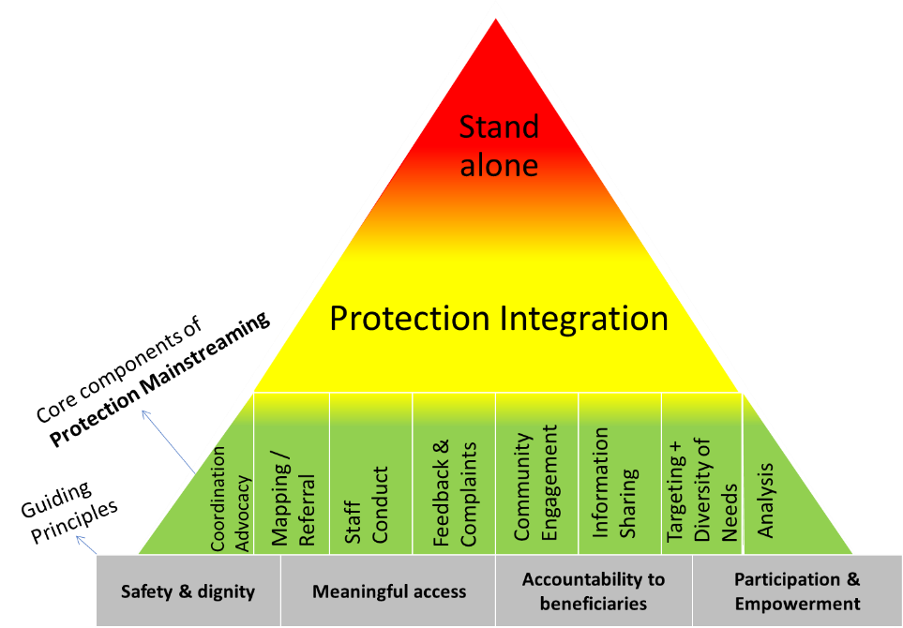
Why is protection mainstreaming important?
Protection mainstreaming can help us improve the quality of humanitarian programming by ensuring the most vulnerable access assistance that is appropriate and relevant to their needs and delivered in a safe and dignified way.

We also have an ethical responsibility to mainstream protection across all humanitarian sectors as our work always has implications beyond meeting basic needs. Interventions can safeguard wellbeing and dignity but they can also put people at increased risk. Failure to mainstream protection may prevent recovery and resilience building in affected communities. Our actions or inactions may also perpetuate discrimination, abuse, violence, and exploitation and unnecessarily cause competition and conflict in communities.
It is therefore a shared responsibility of all humanitarian actors to be aware of the potential harm activities can cause and to take steps to prevent this. These responsibilities are articulated in a number of global standards and guidelines and increasingly a condition of donor funding.
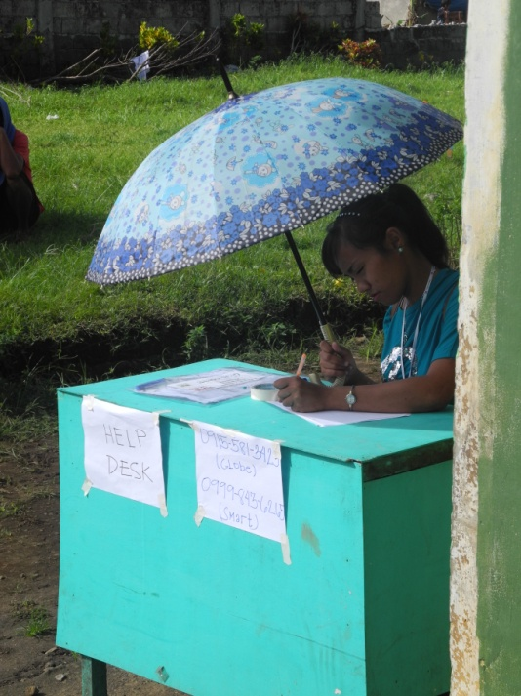
What does it mean in practice?
The four guiding principles outlined on the previous pages underpin the core components of protection mainstreaming. Together these form the foundation for all protection work, from mainstreaming to stand alone projects.

The eight core components comprise practical actions which many teams may already be following but when applied in a systematic way can help ensure the safety, dignity and access of beneficiaries. They comprise:
Photo: Help desk at a food distribution

Components | In practice this means……..
Analysis | All programming is underpinned by an understanding of the protection context throughout the programme cycle. E.g. organise focus group discussions with women and girls to understand their needs and coping strategies.
Targeting and diversity of need | The differing needs and capacities of the most vulnerable women, men, girls and boys are identified and assistance is targeted accordingly. E.g. arrange transport to distribution sites for older persons and people with mobility problems.
Information sharing | Accurate and timely information is readily available to women, men, boys and girls on who we are, what we’re doing and what services are available. E.g. share written and verbal information via leaflets, posters and community meetings.
Community engagement | There is active and inclusive community engagement in all stages of the programme cycle that builds on and strengthens existing community and state structures, resources and capacities. E.g. use different methods, such as timelines, calendars, or mappings to engage different groups.
Feedback and complaints mechanisms | Men, women, boys and girls are able to provide feedback and report concerns in a safe, dignified and confidential manner and receive an appropriate response when they do so. E.g. put in place hotlines, suggestion boxes, or help desks.
Staff conduct | Staff and partners have appropriate knowledge and organisational support to conduct themselves and their work in a safe and appropriate way E.g. orient staff and volunteers on the code of conduct on key facts about the projects.
Mapping/ Referral | Staff and partners have necessary knowledge and information to support communities in accessing existing services. E.g. provide staff with laminated cards listing service providers.
Coordination/  Advocacy | Staff and partners advocate and work together with relevant actors to enhance the protective environment, avoid duplication and to prevent, mitigate and respond to protection risks. E.g. staff raise issues such as unsafe service provision with responsible actors (such as the protection cluster).

The Protection Mainstreaming Working Group (PMWG)
CRS, Caritas Australia and CAFOD have committed to a joint initiative, the Protection Mainstreaming Working Group (PMWG), to strengthen their own capacity and that of their partners in order to be more strategic and consistent in mainstreaming protection throughout emergency response and recovery programmes. The Working Group will seek to strengthen protection mainstreaming through:
    - Building widespread commitment and providing practical support to the implementation of protection mainstreaming;
    - Developing and promoting good practice and continual learning in relation to protection mainstreaming;
    - Ensuring representation and participation within relevant international protection fora;
    - Developing strategic links with the wider Caritas network.
A collaborative approach will “add value” by increasing efficiency, standardising terminology and approaches and sharing resources and learning. Furthermore, working together on certain aspects of protection mainstreaming will maximise our reach and impact, raise our profile (and thus ability to influence) in the international arena and facilitate more effective field work with partners. The triangle framework was developed as part of this collaborative approach.

“Protection mainstreaming” and “safe and dignified programming” may be used interchangeably
Definitions from the Global Protection Cluster: http://www.globalprotectioncluster.org/en/areas-of-responsibility/protection-mainstreaming.html
The colour in brackets refers to the colour-coded triangle which visualises the different protection approaches.
See the Sphere Handbook (2011) p.31: “In order to meet the standards of this handbook, all humanitarian agencies should be guided by the Protection Principles, even if they do not have a distinct protection mandate or specialist capacity in protection”. See also The Centrality of Protection in Humanitarian Action, Statement by the Inter-agency Standing Committee (IASC) Principals, December 2013, available at: http://www.interaction.org/document/centrality-protection-humanitarian-action-statement-iasc

