SWASH /AGR JOINT IN-DEPT NEED ASSESSMENT, GULANI AND GUJBA LGA’s YOBE STATE, DATE OF ASSESSMENT DATE: SEPTEMBER 9TH TO 12TH 2017
Introduction
As a follow-up to the Rapid assessment conducted in Gujuba and Gulani LGA’s on 25th – 27th July 2017, a reassessment was carried out with the following objectives;
- To do an in-depth assessment to determine areas of highest need for commencement of intervention
- To see the possibilities of using integrated approach for both Agriculture/livelihood and WASH intervention.
The Assessment was conducted by Bala Usman, Terry Munyal, Emmanuel S Aimiku, Yakubu Mishara, and two partner staff from NIRA; Ibrahim Mohammed and Abdullahi A. Garba.
Methodology
Different approaches were adopted by SWASH and AGRICULTURE/LIVELIHOODs field staff for the assessment. Approaches adopted by the SWASH include key informant interview, House to house visit and interview, community walk through, while Agriculture and livelihood use the key informant approach and focus group discussion for vendors, women and men farmers.
Executive Summary
The assessment was carried out in four wards selected in Gujuba and Gulani local governments areas, these are Buni yadi and Buni gari in Gujuba LGA while Bara and KuKuwa were selected for assessment in Gulani LGA. The selection of these areas were based on high level of need identified during the rapid assessment conducted in July. In Buni yadi, Kassachia, Ngomari, and Pawari, were assess, in Buni Gari, Malari, Galtamari and Bulama Yaga communities were assess, while Galadima, Galada and Anguwan Aduwa were asses in Bara and Bulabulin, Kukuwa and Lara in Kukuwa ward. Summary of population findings from the assessment were as indicated in the table below. However, these population are not accurate as these is largely obtain from community leaders or community key informant who have no accurate data of the populations of the communities.
GUJUBA LGA
Buni Yadi | Kassachia | 3000HH | Buni Gari | Malari | 5000HH
 | Ngomari | 5000HH |  | Gaitaamari | 2000HH
 | Pawari | 2000HH |  | Bulama Yaga | 2500HH

GULANI LGA
Bara | Galadima | 3000HH | Kukuwa | Bulabulin | 2500 HH
 | Galada |  |  | Kukuwa
 | Anguwan aduwa |  |  | Lara
Assessment Findings
As at the time of assessment, several needs for shelter, water, sanitation, hygiene and agriculture were identified in different communities assess. summary of the identified needs is as presented below.
GUJUBA LGA
Shelter
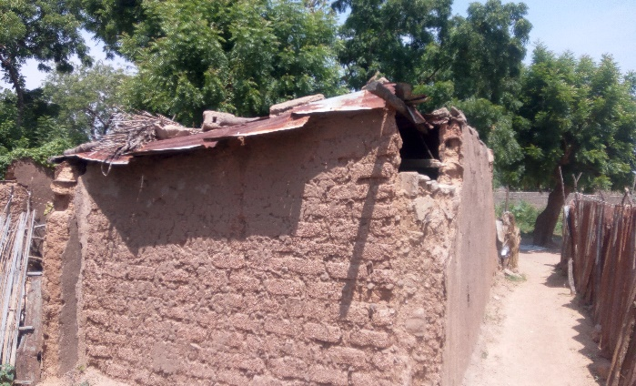
over 70 % of the returnee reside in their own houses, and about 75% percent of buildings are made of mood bricks and zinc ruffing sheet. High needs of building repairs were identified in kassachia community of Buni yadi ward, several HH were found to be residing in uncompleted building or damage buildings, when ask during the interview, most of them indicate that they have returned between five to nine months, and have been residing in the same condition of houses since their return. Returnee house in kasschia community
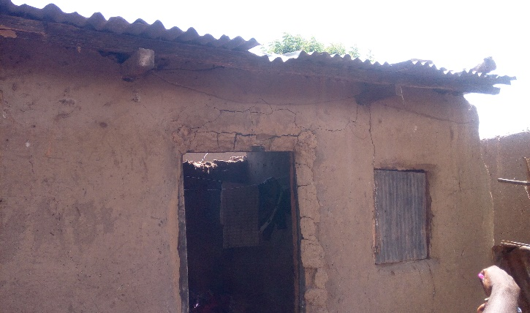
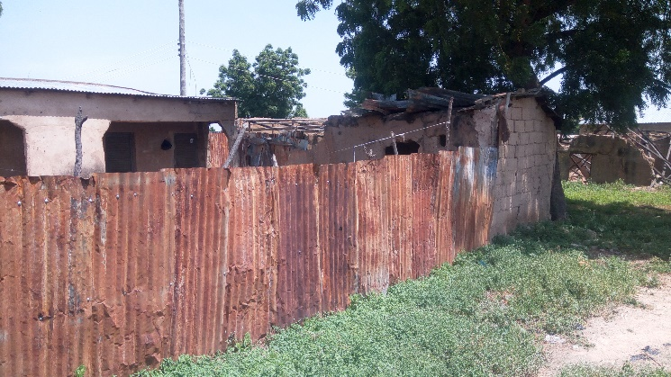

House of returnee in pawari community in a dilapidated condition with no widow and a blow off Ruff.

Water
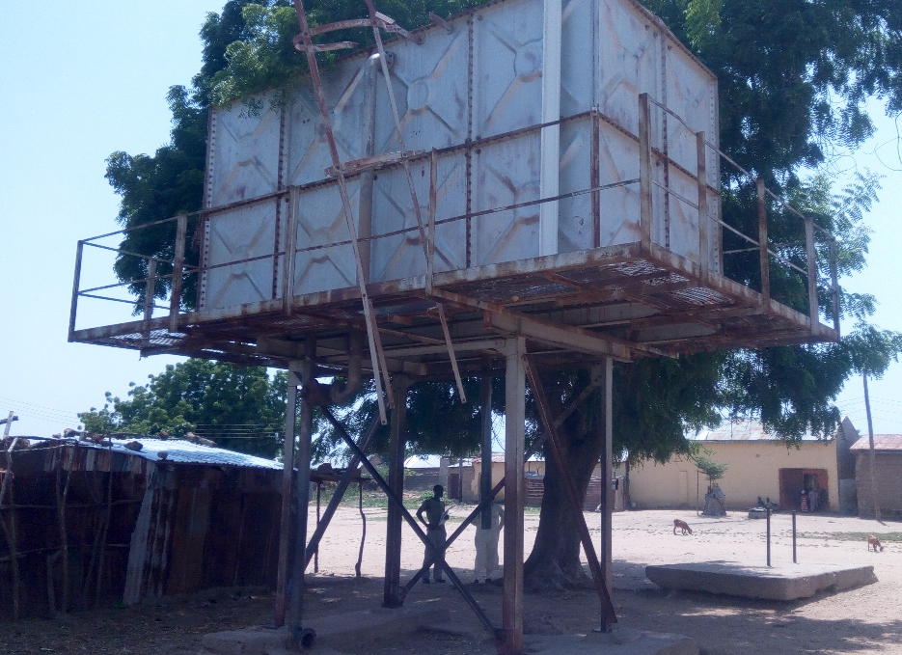
Water supply also seems to be very limited in the three communities assess in Buni yadi, while the situation is similar in Buni gari town, according to the information gain from the community informant, there is only one functional borehole in pawari and two functional in kassachia, while about three motorized boreholes are nonfunctional. Alternatively, community members get water from private boreholes which is usually not available all times and sometimes not all community members can afford to buy. Waiting time is usually long approximately 50 minutes to one hour in kassachia and pawari respectively, information from household’s interview indicate that sometimes family members stay without taken their bath or have to suspend some domestic activities like washing for lack of water. However, as at the time of the assessment, ICRC was seen drilling one borehole in front of the Village chief of Buni yadi. Which obviously will not be able to solve the entire water needs of the community.
Sanitation
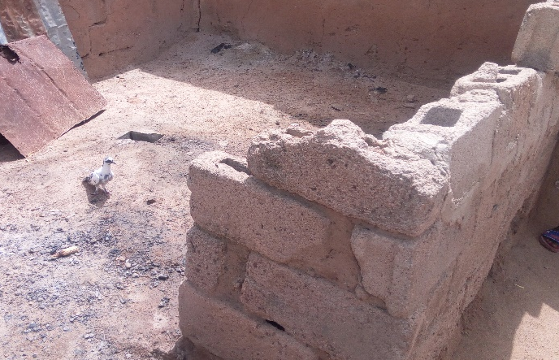
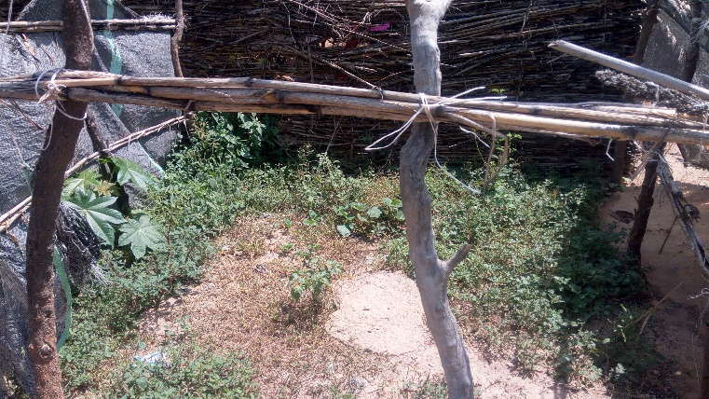
In over ten HH interviews conducted in kassachia, pawari and Ngomari, only three (3) household have locally constructed traditional pit latrines, the others have no latrines at all within the households, there is a huge gap in sanitation in all the three location asses in Buniyadi ward Gujuba local government area. Similar condition was also found in Buni gari, as most HHs have either no latrines, nonfunctional latrines or poorly maintain local pit latrines.

a site demakated by a HH site in kassachia a soak away pit with no fence currently
community for open defecation and bathing in use by a HH as a latrine.
Hygiene

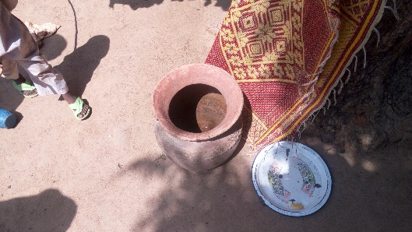
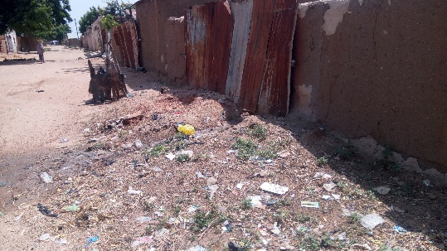
personal, Environmental and domestic hygiene is very poor in the communities assess, many households visited store their drinking water in dirty containers, and some in wide mounted containers with improper handling and some in dirty jerrycans with no covers. Children were seen dirty within the HH and with no proper hygiene, from the information gain from the HHs interviewed, diarrhea, rashes and other skin related diseases are pronounced among children age below 15 which usually surfaces during rainy season, few human faces were also seen around household area. Other finding includes presence of dirty garbage’s improperly disposed closed to houses, and houses channeling their waste waters directly outside the compounds without control. Few individuals interviewed also said they only wash their hand after visiting the latrines and before eating.

Agriculture/Livelihoods
In Gujba Local Government Area the assessment team assessed two wards Buni Yadi and Buni Gari.
BUNI YADI (GUJBA LGA)
The agriculture/livelihoods assessment in Buni Yadi revealed that agricultural activities are the major source of income which constitute 70% of the population engaging in rain fed farming as there is limited supply of water in the area, water source is rain fall and constructed drilled bore hole. The communities assessed in Buni yadi are Kasaschia and Ngomari. The major source of income in Kasaschia/Ngomari is cultivation of crops/vegetables (beans, sorghum, sesame, maize, groundnut and bambara nut, onions, tomatoes, pepper), rearing of livestock animals (sheep, goat, cattle and poultry) of which they have never received trainings on either crop production or livestock production, few among the population engages in petty trading as source of income. Apart from farming other source of livelihoods are trading, carpentry, tailoring and mechanics. The size of farm ranges from one (1) hectares to three (3) hectares as their irrigation farming activities are restricted by the military due to security challenges. The major challenges when growing crops in this area is drought and insect-pest while for the animals is insufficient animal feed/vaccines.
The major community need in Buni Yadi according to priority are; water, food assistance and farming inputs such fertilizers, herbicides and pesticides.
There is a functional existing market in Buni Yadi were community members purchase there seeds local and hybrid varieties from vendors while others store seeds gotten from last season in anticipation of planting in new season. The vendors/shop owners get their stocks from Damaturu and Kano. The vendors itemize the major challenges of farmers in the area to be ploughing and harrowing equipment’s, pesticide/insecticides and fertilizers.

BUNI GARI (GUJBA LGA)
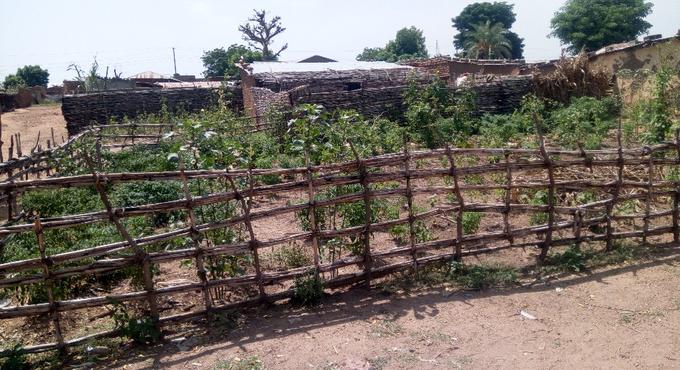
Two communities were assessed in Buni Gari: Malari and Bulama Yaga communities. In Malari farming activities are carried out by 70% of the population engaging in the cultivation of crops/vegetables (maize, sorghum, beans, rice, groundnut, sesame and bambara nut/tomatoes, melon, onions, pepper and sugarcane) and rearing of livestock animals (goat, sheep and poultry). The farmers in Buni Gari haven’t receive any training that pertains to crop production or livestock production. Their major challenges in crop production in Malari are; no availability of improved variety of seeds, pesticides/insecticides, fertilizers and water engine pumps for dry season farming. while for the livestock production vaccines is the major challenge.

Backyard garden in Malari
The major source of water in this area are drilled borehole, well water and river though the river dries off soon after the raining season is past.
There is no defined functional market for agricultural inputs within the area, farmers get their seeds from reserved seeds from previous seasons/from the closest market available which is the Biu market and Gombe.;
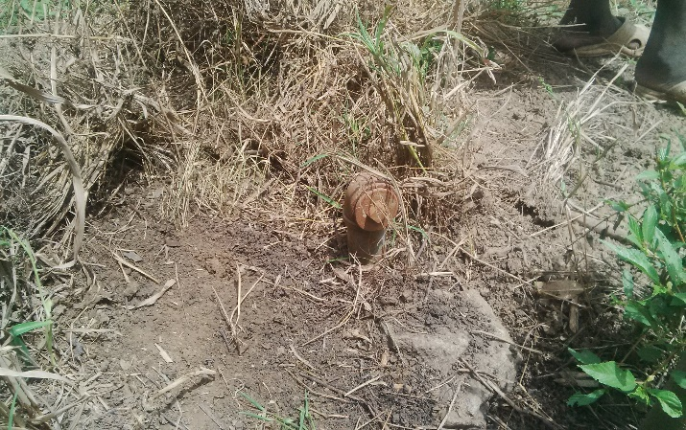
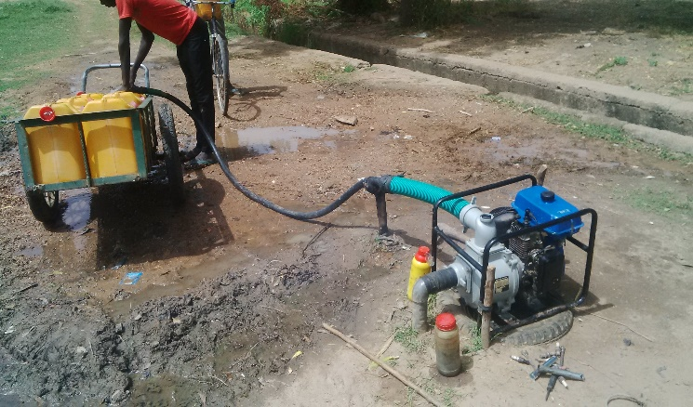
Bulama Yaga a community in Buni Gari ward having a population of about 2500HH from which about 60% are engaged in farming activities, cultivation of crop/vegetables (sorghum, maize, beans, rice potatoes/salads, onions, pepper) and rearing of livestock animals as (goats, sheep, cattle and poultry). The farmers in Bulama Yaga have not receive any training that relates to crop production or livestock production. The farm size in Bulama Yaga ranges between one (1) hectares to six (6) hectares of land. The major source of water is drilled borehole, wash down borehole for irrigation and river water but the river doesn’t flow all through the dry season. Most of the farms in Bulama Yaga community have a wash down bore dug about five (5) years ago but lacks the motorize engine pump only few percent of the farmer population have the water pump engine. There major challenges in Bulama Yaga are insecticides/pesticides, pipes and pumps for off rain season cultivation, availability of good seeds, as seeds are gotten from other communities and nearby markets (Biu market, gombe market) of which sometimes the seeds don’t do well.
Wash down bore hole in farm at Bulama Yaga Functional wash down bore hole in Bulama Yaga

GULANI LGA

Bara and Kukuwa wards were among the worse heat during the insurgency, as a result, several needs were identified during the period of the rapid assessment, the follow up need assessment focus on possibilities of integration of WASH and Arg. Activities in these locations and detail findings of WASH/Agriculture and livelihood needs in the wards. findings of the needs identified are as follows;

Shelter

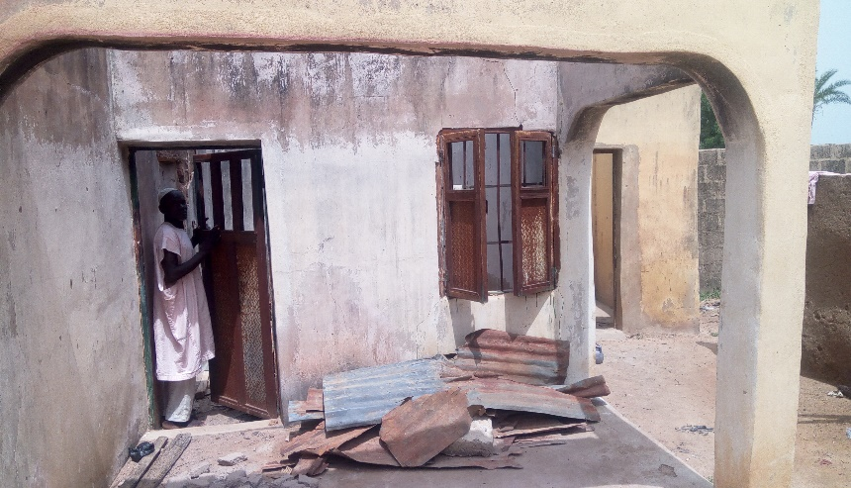
Shelter needs are not much visible as in Gulani, in both kukuwa and Bara Wards, most families have return to their shelters and are living in a better condition compare to assessment findings in Gujuba LGA. 75-80% of shelters were made of moods and zinc ruffing, however, the returnee have renovated most of the shelters though few needs are still visible as some families are still leaving in shelter with no windows or doors, while some houses ruffing are in a state of collapse.

Part of the house of village head of bara destroyed
Water
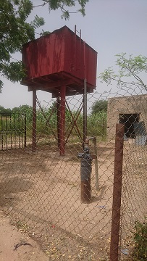
The assessment result observed limited access to water supply in Bara and Kukuwa towns of Gulani LGA. Three locations where assessed in Bara town which include Gala Chiroma, Gala Dala and Maiduguriyel. There are four existing boreholes in these communities, however, only one of the borehole is functional. Based on the opinion of most of the community members that were interviewed, the most pressing need in Bara is access to potable water supply. On the other hand, there are three existing boreholes in Kukuwa town, however, only one of these borehole is functioning. The assessment also observed presence of ACF in Kukuwa town. ACF is presently drilling additional borehole in addition to other activities they are currently carrying in this area.
A non-functional borehole in Bara

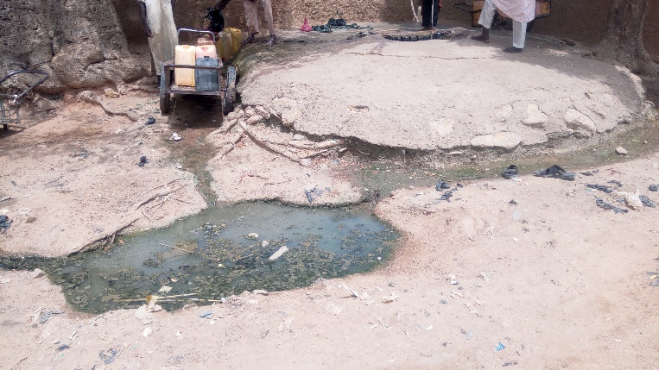
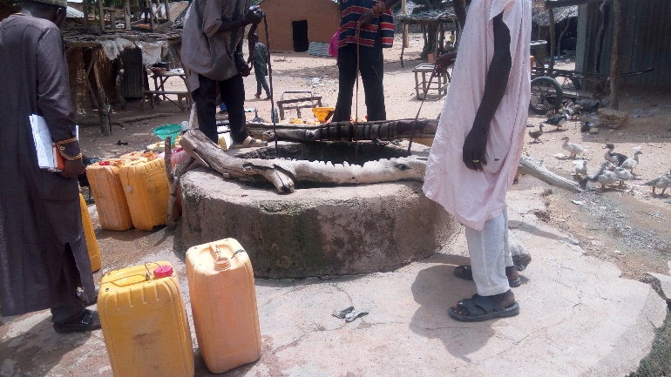

Open wells used for fetching drinking water in in Bara community due to insufficient borehole water supply.
Sanitation
Sanitation facilities are mostly locally constructed pit latrine without concrete and in most case no privacy as they are mostly fence either by rags or half fence with woods. High percentage of HHs in Bara don’t have a latrine and mostly result to defecating outside in nearby Bushes. In addition, mostly HHs have their bathing water directly flowing outside their HHs to a nearby street without any soak pit their by posing a Danger diseases.
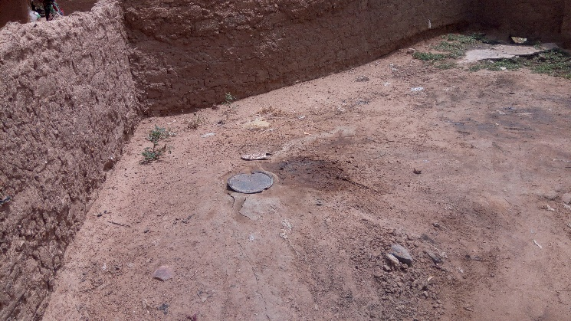
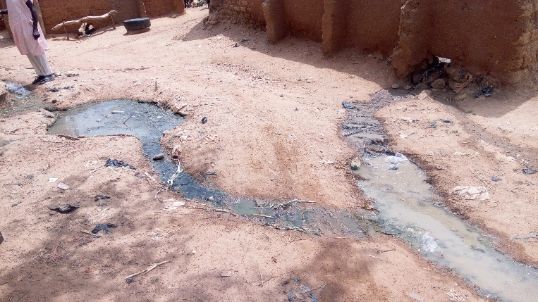

Water flowing out of a shelter in a HH in Bara A HH pit Latrine -Bara
Hygiene
Hygiene behavior is relatively good in some part of the communities as some household have good environmental hygiene practice with compounds clean and no much presence of solid waste around the community, however few presences of faces were observed in some areas which is due to the fact that some HHs have no latrine in their compounds. From the information receive from key informant, hygiene related diseases like skin rashes, diarrhea, eye infection are not much prevalent in the community.

Agriculture/Livelihoods
In Gulani local government area of Yobe state two wards were assessed; Bara Ward and Kukuwa Ward
Bara Ward (GULANI LGA):
In Bara Ward the agriculture and livelihoods team assessed three communities; Gala-Chiroma, Galadima and Gala-dala of which 95% of the population depends on farming as source of livelihoods. The farmers in Gala-Chiroma engage in crop production of maize, sorghum, cassava, beans, maize, millet and vegetable crop production of onions, tomatoes, water melon, pepper and salad. Their farm size ranges from 0.5hectare- 5 hectares of land. The farmers get their seeds from reserved seeds grown previous season while few get there’s from the Biu Market. The farmers in Bara have not received in trainings on crop production or livestock production. There challenges in Bara ward associated with crop production are lack of equipment for ploughing, insecticides, good seeds and fertilizers. The farmers also rear animals as goats, sheep, poultry, the challenge faced with the livestock production is feeds are not sufficient as there is insufficient grazing land.
The water source in Bara is rainfall, drilled bore hole, few farmers engage in dry season farming digging a shallow well using channells for irrigation of farm lands as the water table is high just few meters below the ground, they create water channels to irrigate their farm lands.
There is no functional market where farmers get reliable seeds from, seeds obtained are either from last season or bought from neighboring market (Biu, Gombe or Bajoga market). Farming tools are locally produced by black smiths.

Kukuwa Ward (GULANI LGA)
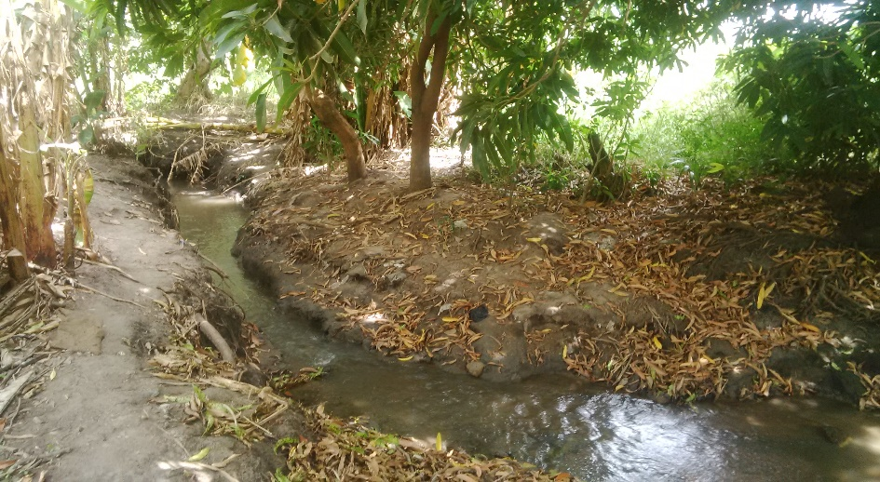
In Kukuwa ward two communities were assessed; Kukuwa and Bulabulin. Kukuwa has a population of 2500HH, about 80% of the population are engaged in cultivation of crops and rearing of animals. Crops grown in kukuwa are sorghum, maize, groundnut, sugarcane, cocoyam beans and sesame, vegetables such as tomatoes, pepper, onions. The farmers in Kukuwa have not had any training that pertains to crop production or livestock production. Seeds are gotten from previous seasons and neighboring market. Livestock grown in Kukuwa are sheep, goat and poultry. The major challenges faced in crop production are insecticides/pesticides, fertilizers, pumping engines, while the livestock production challenges are animal feeds and vaccines.
The main source of water in Kukuwa community are drilled bore hole, spring water that flows all year round and well water. The kukuwa community engage in rain fed and dry season farming making channels and path ways for water though this is not efficient for farm lands a little further from the water source.
Bulabulin is a community in kukuwa Ward having about 800HH of which 90% are engaged in farming activities. They are engaged in crop/vegetable production (maize, sorghum,groundnut, beans/pepper, tomatoes) and also livestock production(goats, sheep and poultry). Seeds for cultivation are gotten from previous season while few farmers bought their seeds from the available close market market. The farmers in Bulabulin have not received any training on crop production or livestock production. The major challenges of crop production are insect-pest, fertilizers, herbicides and seeds. While for the animals there is insufficient feed and no vaccines. Source of water is rainfall and channeling of water from the spring source, this is usually difficult as there is a distance between the source of water and the community along the way the water channel be closed.
Summary of Assessment- Agricultural/livelihood

LGA Assessed | Wards/communities | Land Space | Training Received on (crop Production and livestock Production) | Availability of Functional Market (Vendors) | Water source for Agricultural Livelihoods | Challenges / Needs for Agricultural activities
Gujba | Buni Yadi | Restricted by Military activities due to security challenges | None | Yes | Rain water | Water, food, lack of good seeds, pesticides, herbicides and fertilizers
Gujba | Buni Gari | Available for both Raining Season and Irrigation Farming | None | Partially present (not Strong) | Rain fall for wet season and wash down bore hole constructed at farm land for irrigation. | Lack of reliable seeds, engine pump and pipes for irrigation, plough, pesticides and fertilizers.
Gulani | Kukuwa | Available for both Raining Season and Irrigation Farming | None | Partially Present (CRS vendor Present) | Rainfall for wet season and Spring running water for irrigation | Pesticides, herbicides, lack of reliable seeds, fertilizers, water pumps and pipes.

From the assessment there are no present organization supporting with Agricultural and Livelihoods activities.
Summary of the findings/conclusion

SWASH
From the detail assessment conducted, the following gaps were identified in locations asses,
- There is a Huge gap in shelter with need of shelter repair as a major gap identified
- Water supply is a visible need in both Gujuba and Gulani communities as most of the location asses where without good water supply system or in some cases insufficient water supply for personal and domestic uses
- Major gap in sanitation especially in hard ware facilities (latrine) as most HHs have no or non-functional latrines.
- Hygiene practises of some of the area asses is very poor hence the need of hygiene promotion
- NFI is highly needed as interaction with HHS shows that most of them don’t have the basic needed items for proper storage of water and lack soap for hand washing.

Findings of the assessment indicate that markets are not fully functional is Buni gari, Kukuwa and Bara, however, the market is relatively functional in Buni Yadi community where CRS already have chains of vendors participating in food distributions. Construction materials like zinc sheets, woods, cements and blocks are also available in Buni yadi community, price of cement in Buni yadi is found to be same as in Maiduguri where a Bag of cement cost 2700 Naira. Other farming materials are like tools seeds are mostly purchase in Buni yadi Markets.
Market functionality
Recommendations

SWASH
Program recommendation made During the rapid assessment in July should be implemented, for SWASH activities, we recommend that intervention be implemented in Kassachia, pawarri situated in Buniyadi ward and malari situated in Buni gari ward. Reasons includes;
- Huge SWASH need identified in these locations
- No other INGO currently implementing SWASH activities there
- Functionality of the market
- Presence of CRS through FFP intervention
Agricultural/Livelihoods
Base on the Agriculture/livelihoods assessment carried out in Gujba and Gulani, Local Government area of Yobe State for the project OFDA running from (September-May) 2017, indicating an off-rain season Agricultural activity. All LGA accessed has needs for agricultural interventions varying with different needs and priorities with no technical training on either crop production or livestock production cutting across all areas assessed. Based on the project time frame which is a dry season agricultural activities, water and available land space is a necessity therefore I recommend agricultural activities in the following locations: communities of kukuwa in Gulani LGA, buni Gari in Gujba in LGA and Bara of Gulani LGA.
To achieve optimum production in agricultural activities, smallholder farmers can benefit from tailored training. Farmers are often unfamiliar with modern agricultural practices or innovative technologies, the use of which can lead to significant productivity gains compared to existing local methods. Appropriate training programmes can play a critical role in bridging this gap, providing farmers with the new skills and technical knowledge necessary to implement improved methods and to make informed decisions about the best options to suit their needs.

