Advantages and disadvantages of CTP delivery mechanisms

Agent | Minimum conditions | Advantages | Disadvantages
Using third parties such as banks, remittance companies, post offices
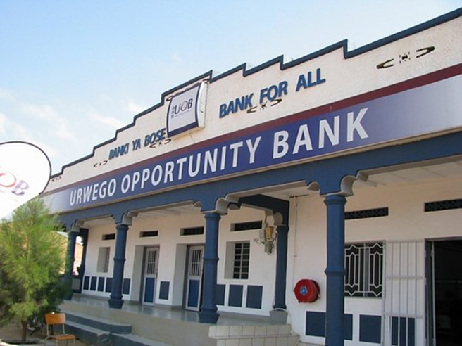 | Bank regulation | Financial risk managed by agent | Slow contracting
 | Robust software systems | Financial inclusion and literacy | Financial literacy required
 | Meet finance criteria | Existing networks | Lack of accessibility of services
 | Existing contracts | Large scale | Requires accurate data
 | Community acceptance |  | Formal identification
Using third parties such as mobile phones or E- wallets (mobile money) providers
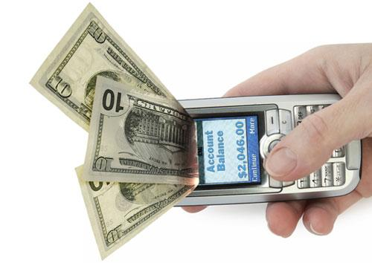 | IT assessment | Reduces paperwork | Often unregulated
 | Reliable network | Reduces workload | Expensive
 | Availability of payment software | Reduces fraud risk | High initial investment
 | Point of sale (PoS) capacity | Large scale | No ability to restrict household purchases
 | User capability | Fast, safe transfers | Limited ability to restrict food purchases
 |  | Flexibility for beneficiaries
Direct cash distribution by the Movement (or a third party) to the beneficiary
 | Secure context required for transportation and distribution | No formal identification required | Security risk for organization and beneficiaries
 | Sufficient cash flow | Facilitates limited literacy and numeracy | Corruption risk
 | Sufficient staff, logistics and other resources | Fast set-up | Labour intensive
 | Political acceptances | Large scale | Significant monitoring required at payment
 | Community acceptance | Often low cost | Limited ability to restrict food purchases
Using retailers (electronic and paper vouchers)
 | Trader acceptance and capability | Low cost | Time to set up
 | Large number of traders required | Limited literacy and numeracy required | Sensitization and acceptance of traders
 | Easy, familiar access for beneficiaries | Large scale operations possible | Scale is limited by trading capacity
 | Diverse range of stock | Transfer values can be adjusted | Distribution costs can be high
 | Secure way of paying traders | Ideal for conditional CTP | Forgery and misappropriation

