Community Safety Mapping 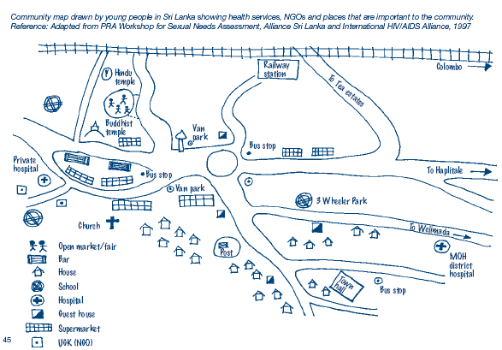

A safety mapping exercise involves members of a local community mapping out the important local facilities in their neighbourhood and the areas where they feel safe and the areas they feel are dangerous.
- Detailed mapping with:
  - Red highlights on place they feel safe
  - Yellow on places they believe are dangerous
  - Symbols for threats, times of danger
A table can then be filled out highlighting:
Threat | Where | Time | To Whom | What to do

