Setting cash transfer values for general and sectoral needs

In this guidance, you will find basic guidelines for setting the cash transfer value for general programs, as well as sectoral programs including food, shelter, WASH, and specialized needs.
Contents
I. GENERAL OR MULTIPLE NEEDS 1
How much of the MEB should your cash transfer cover? 2
Linking with government social assistance programs 2
II. FOOD. 2
III. SHELTER. 3
Using tranches to ensure quality in shelter programs 4
III. WASH. 4
IV. OTHER. 4

I. GENERAL OR MULTIPLE NEEDS. For general or multiple needs, set the CT value based on an estimate of what items and services people cannot access through their average incomes. Use a Minimum Expenditure Basket (MEB) to determine what people’s monthly needs are, compared with an estimate of what needs they’re able to meet without aid. See this guidance here on creating a Minimum Expenditure Basket. Below is an example of an MEB from Nepal.

Item | Unit | Quantity per HH of 5 per month | Price per unit | Total price per month
Rice | Kg | 63 | 0.45 | 28.35
Dried pulses | Kg | 14 | 1.4 | 18.90
Oil | L | 4 | 1.28 | 4.80
Milk (cow/whole) | L | 9 | 0.68 | 6.12
Leaves (Dark Green e.g. Spinach) | Kg | 15 | 0.75 | 11.25
Salt (iodised) | Kg | 1 | 0 | 0.00
Eggplant (Augbergine) | kg | 7.5 | 0.35 | 2.63
Inidividual soap | Pcs | 12 | 0.25 | 3.00
"Piyush" water guard liquid chlorine | Bottle | 1 | 0.45 | 0.00
Water Container | Bottle | 1 | 3.5 | 3.50
Bath soap | Bars | 12 | 0.3 | 3.60
Laundry soap | Block | 1 | 0.8 | 0.80
Sanitary Napkin | Piece | 24 | 0.1 | 2.40
Transport | Lumpsum | 1 | 2.5 | 2.50
Mobile phone top-up | Lumpsum | 1 | 5 | 5.00
Extra | Lumpsum | 1 | 10 | 10.00
Inflation | Lumpsum (5% of total) | 1 | 10 | 5.14
 |  |  | TOTAL US$ | 107.99
70 % of MEB |  |  |  | 75 US$

How much of the MEB should your cash transfer cover?

In Nepal, the MPG value was based on a common understanding of the daily basic needs of households in the earthquake-affected districts. It was recommended that 70% of the Minimum Expenditure Basket (MEB) should be provided through multi-purpose cash grants. This was based on data indicating that people could cover about 30% of their needs on their own. The Cash Coordination Group in Gorkha District, led by CRS, set the value of the Multi-Purpose Grant cash transfer for livelihood assistance at US$75 according to the national MPG operational guidelines.

Linking with government social assistance programs. If there is an ongoing government social assistance program, be sure your cash program is appropriately linked to it. You may need to consult local or national government before beginning your program.

If your program has specific sectoral needs, consider the below:

II. FOOD. For specialized food needs, set the CT value based on a food consumption gap. (See diagram below.)
[Source: WFP. 2014. Cash and Vouchers Manual. Rome. p.43.]

To set the cash transfer value for food programming:

- First, identify main foods in the local diet that make up 2,100 kcal/ p/ day, considering adequate protein, fats, and micronutrients.

- Identify the food gap your program seeks to address (see above table).

- Create a list of local foods that can fill the food gap; this is your food basket.

- Estimate the cost of each item in the food basket, and provide enough cash for people to be able to meet their consumption gap.

- If specific nutritional outcomes are expected, use either conditional cash, vouchers, or in-kind assistance to assure consumption of specialized nutrition.

III. SHELTER. For specialized shelter needs, set the CT value based on costs of shelter materials and services; assume that people will also spend some of their cash on food or other needs. Use an MEB, with additional costs for shelter.

Below is a screenshot of part of an MEB used in Nepal. In addition to food, water, and basic items, it included some shelter and NFI materials that people would likely need to purchase once only.

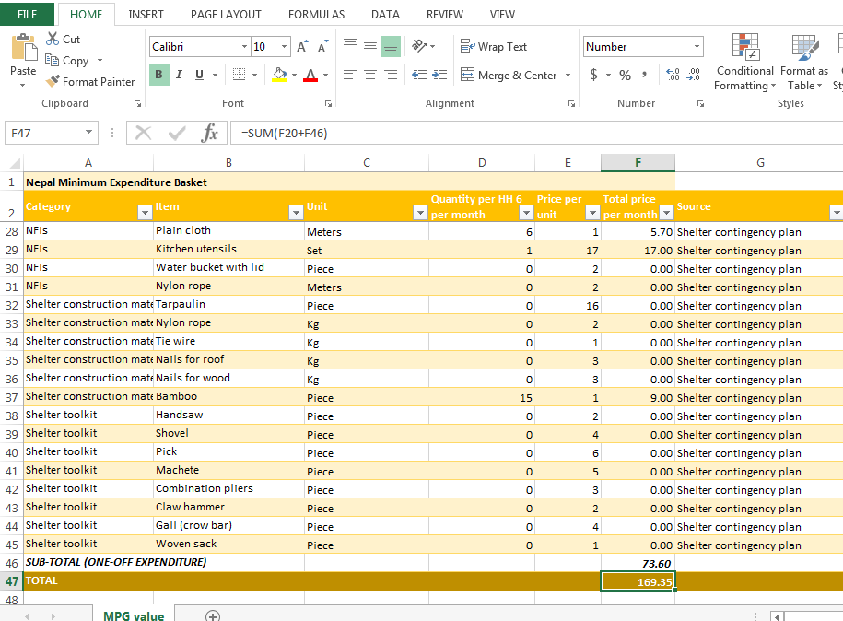

Using tranches to ensure quality in shelter programs

If quality is a concern, consider providing cash in tranches, with the next tranche given if housing specifications are met. Here is an assessment used in the Philippines to ensure quality before providing beneficiaries the next tranche (see Annexes, pp.11-16).

III. WASH. For specialized WASH needs, set the CT value based on costs of WASH materials and services; assume that people will also spend some of their cash on food or other needs. Use an MEB, with additional costs for WASH needs.

The above MEB from Nepal includes some WASH needs, as an example.

IV. OTHER. For other specialized needs, create a Minimum Expenditure Basket, with additional costs for specialized needs. Remember that, if needs are very specialized or require behavior change, then vouchers, conditional cash, or in-kind may be the best responses.

