Technical Note - Options for the supply of materials
This brief note is to outline options for the supply of materials for shelter construction and recovery, where the affected communities and households are provided the best options for access to appropriate materials. This also looks to effectively utilise local markets and suppliers to expedite the supply of materials and provide the greatest choice.
Objectives:
- To provide choice of materials to meet the variety of construction needs
- To provide a supply of materials that allow construction standards to be met
- To ensure the timely supply of materials to meet the housing recovery needs
- To provide best value and mitigate against inflationary factors
Issues:
- Ensuring that the correct materials are purchased and used properly
- Access to vendors and the logistics of delivery
- Developing systems for different modalities
- Completing procurement processes to provide materials to be timely

Options

In-Kind:
Where materials are purchased by the agency and delivered to the beneficiary
- Where beneficiaries all want the same commodity this is appropriate but does not work where people all require different materials
- Allows for bulk purchase and options for direct imports to maximise cost benefit and guarantee quality
- If locally procured, this can be quicker than other options. This may be used as an option to allow programs to start while developing other modalities
- May be the only option when there are particular logistic constraints, such as remote islands

Cash:
The option for using unconditional and unrestricted cash may have issues for the following reasons:
- Limited number of people with bank accounts
- Protection issues around providing cash
- Issues of demands and expectation for the cash to be used to assist others or repay debts
- There is no control over the quality of material that is supplied
- Reluctance by government, communities, and NGO to use Cash
Vouchers:
Vouchers with a monetary value can be used to be exchanged for materials.
- Possible to negotiate rates of selected materials with suppliers
- Possible to restrict the supply of some materials. For example, only CGI of the correct quality can be exchanged for a voucher
- Can be used with more than one vendor, allowing negotiation around cost and supply
- Communities can group purchase to get best rates and also to reduce delivery costs
Catalogue:
A Catalogue of the most common building materials that allows the buyers to select the materials they want and then complete an order up to the value of their grant.
- Allows choice of materials, although can limited to certain items and therefore provides an opportunity to focus on particular construction objectives, such as roofing and fixings
- Provides control over cost and quality
- Reduces protection issues
- Allows for logistic efficiencies

Advantages and Disadvantages are summarised in the table below:

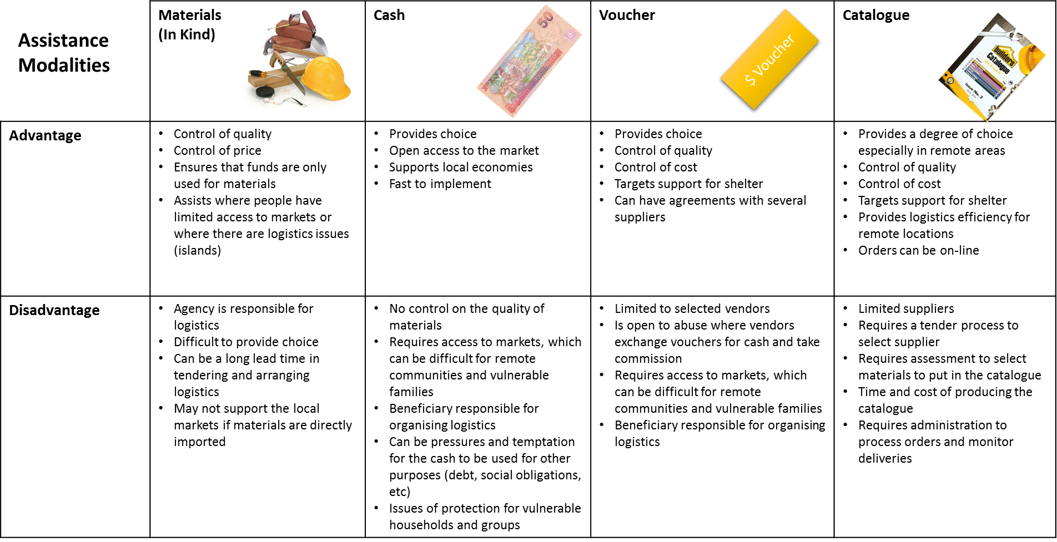

Strategies

Where communities and householders can access markets then the Cash or Vouchers may be an option. For Cash to be used, there needs to be vendor options so that there is competition to allow price negotiation. If there are limited number of vendors or communities are some distance from stores, the catalogue system provide choice and allows the agency to negotiate prices, and guarantee the quality.
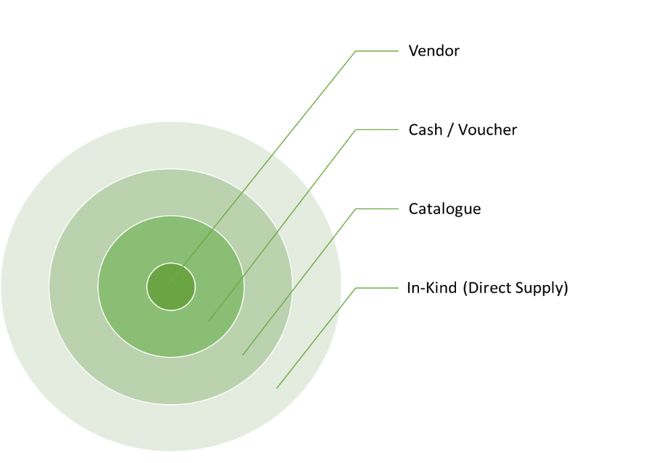
Where the distance to the stores is too great, there is a need for the same commodities, or to expedite deliveries, then direct delivery may be the best option.

It may also serve the program to have a combination of modalities such as direct delivery of universally needed items such as tools and fixings and then a voucher or catalogue approach for other materials.

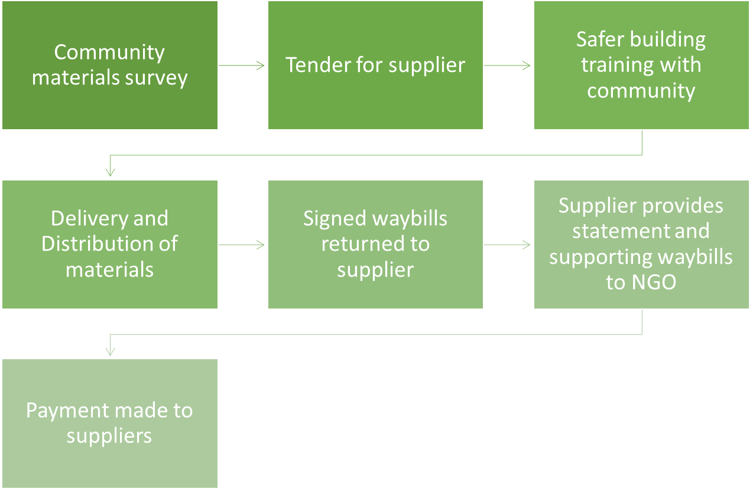
In-Kind / Direct Delivery

Voucher
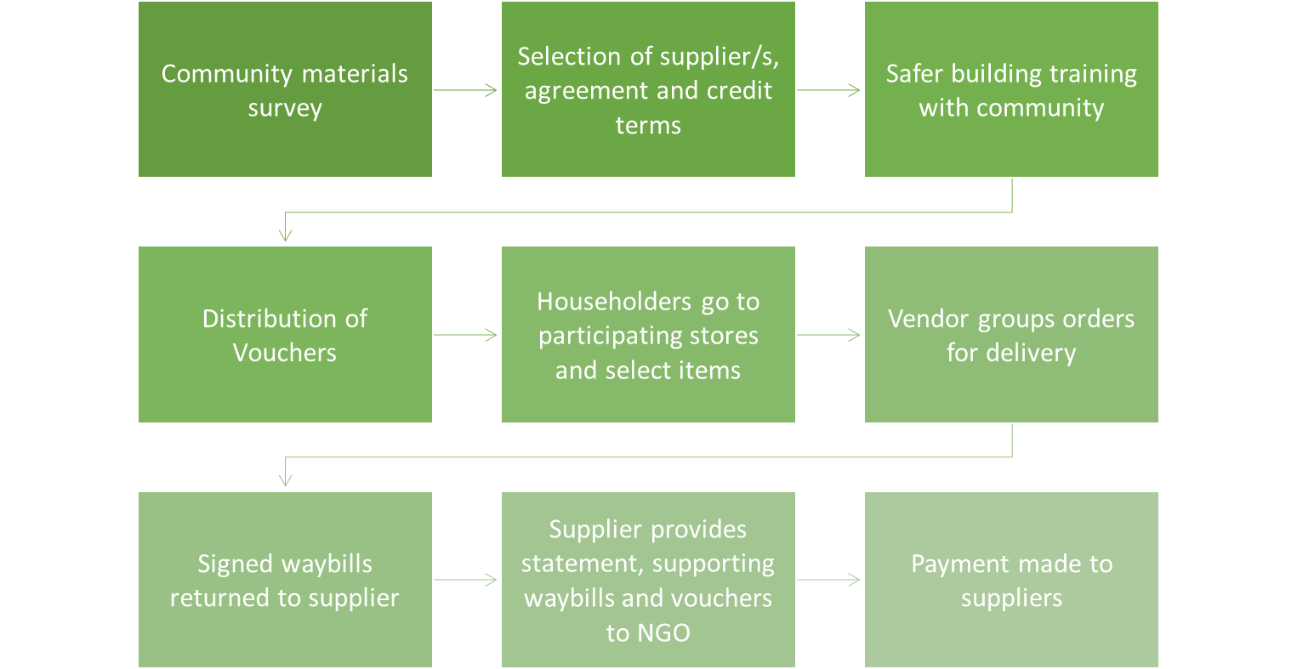

Catalogue

Building Suppliers in Fiji:

http://www.yellowpages.com.fj/categories/Hardware+Retail/

Links and References
http://www.cashlearning.org/downloads/gscpositionpapercashandmarketsinthesheltersector.pdf
http://www.cashlearning.org/english/home
https://www.sheltercluster.org/library/shelter-and-cash
https://www.sheltercluster.org/sites/default/files/docs/Cash%20and%20Vouchers%20Manual.pdf
https://drive.google.com/folderview?id=0B6Kk7iClxhjhVVhYSEN4eVgtRUk&usp=sharing

