WORKSHEET 6: CONSTRUCTING A MARKETSHED MAP

What is it? A marketshed map is a local, regional, or national map plotted with information collected during key informant interviews and focus group discussions. Market maps can be quick and simple, can be layered on existing maps, and are most useful when focusing on issues of local importance.

Using a map (e.g., a simple road map) of the nation, plot information collected from traders, from supply chain and marketing margin analyses, and from market integration analysis. Identify the main marketing hubs and include approximate numbers of retailers and wholesalers operating in various localities. As information becomes available, identify supply shortfalls, infrastructure damage, or certain routes not considered adequately profitable by traders. Adams and Harvey note that some areas may have few or no traders, because entitlement failures have hurt local purchasing power and traders cannot profitably operate in those regions. Mapping can help identify such areas and alerting traders to impending cash distributions may give them incentives to resume trading in such regions. An additional mapping strategy is to draw lines connecting pairs of markets with strongly correlated prices for the staple crop. Also assess whether transportation of commodities from the source market to the destination market faces any barriers along the route (e.g., export restrictions, customs delays, diversions).

To generate a marketshed map:
- First, find a map with the resolution you are looking for, or draw one by hand.
  - The level of detail will depend on what geographic area the map is trying to capture. For example, it can be hand-drawn for a community market map.
- Assess whether seasonality affects trade routes, source markets, number of traders operating, market choices of targeted households
  - If so, create maps by season
  - Different regions may have different seasons (e.g., unimodal versus bimodal)
- Then, map findings from key informant discussions regarding:
  - Main market hubs utilized frequently by food insecure population
  - Smaller markets also utilized by the same population
  - Storage facilities or centers
  - Major supply markets used by wholesalers and retailers in the marketshed
    - Secondary data may already be collected for larger markets that link to affected marketsheds
  - Market routes and roads
  - Any infrastructural damage in the markets or along main route
  - Prices of key commodities in each of the markets
  - Approximate number of retailers and wholesalers
  - As data become available, it is possible to incorporate supply chains, policies and practices, and market integration.
- For local and regional procurement source markets, also consider including:
  - Production and food supply estimates (FAO /GIEWS; food balance sheets).
  - Routes prone to disruptions, e.g., due to flooding, conflict, customs delays
Limitations of market mapping
A quick mapping of markets focusing on key attributes can identify those most at risk of poor functioning (e.g., isolated regions with fewer roads and limited linkages to major surplus or import markets). However, if a response will be geographically dispersed, a detailed mapping of all markets may not be feasible.

In cases where infrastructure has been damaged or routes or markets are blocked, market mapping is a rapid way to assess the existence of alternative routes and alternate, secondary markets. Mapping the market may provide basic, but limited, context, particularly in regions of chronic food insecurity.

If prices have changed within a distribution zone or procurement zone, market mapping may usefully identify (or rule out) any market-specific factors that may be causing price changes (e.g., infrastructural damage, breakages in supply chains, out-migrations of traders, localized production failures, increased reliance on markets by households within the marketshed, local security threats).

Sources of information: Key informant interviews with traders, government officials, field staff, and local community members

Example: Map of maize production and trade flows
Figure 1: FEWS-NET Maize Production and Market Flows in Kenya and Tanzania
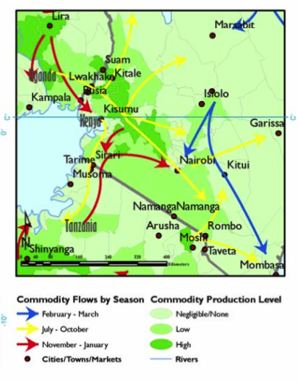
The FEWS NET map in Figure 1 identifies how maize production flows within the region of northern Tanzania, western Kenya and eastern Uganda throughout the year. This map identifies prospective surplus producing regions as well as regions that tend to import maize. Note that maize flows from Tanzanian border areas into Kenya match with the bimodal ‘long rains’ maize harvest time. A maize production failure in a surplus region could adversely affect neighboring importing regions. Assessing whether neighboring markets have linkages to other surplus markets or to import markets will elucidate market integration and traders’ abilities to respond to increases in demand.

Source: Awuor, T. (2007) “Review of Trade and Markets Relevant to Food Security in the Greater Horn of Africa: A special report by the Famine Early Warning Systems Network (FEWS-NET).” P. 24

Adapted from “Lecture 8: Market mapping” of the MIFIRA course materials, Chris Barrett and Erin Lentz, 2010. Available from http://dyson.cornell.edu/faculty_sites/cbb2/MIFIRA/course/
Adams, Leslie and Paul Harvey. 2006. “Learning from cash responses to the tsunami: Issue Paper 1 - Analysing markets.” September. Humanitarian Policy Group: Overseas Development Institute, London.
Timmer, C. P., W.D. Falcon, and S.R. Pearson. (1983). Food Policy Analysis. Baltimore: Johns Hopkins University Press: Chapter 4, “Marketing Functions, Markets, and Food Price Formation.”

