WORKSHEET 3: ASSESSING INTERVENTION EFFECTS ON PRICES

In assessing whether the intervention is having an effect on prices, there are two ways of looking at the available information. 1) You can check when the price changes happen in regards to the distribution schedule, and 2) you can compare prices in intervention markets with prices in comparison markets.

When do the price changes occur in the intervention calendar?
One of the most critical factors for attributing price changes to an intervention and understanding the potential impacts of the price change on the intervention is the temporal linkage between the price change and the distribution. For example, if prices were to spike immediately after a large scale cash distribution, this might indicate that the intervention increased prices as more consumers had the resources to purchase food in a thin market with limited food supplies.
How to do it: Create a graph of the commodity you are concerned about with prices from the relevant markets. Keep the x-axis to a relatively short timeframe so you can indicate the dates of any distribution or other type of intervention clearly on the graph. Look for whether price fluctuations are associated with the timing of the intervention.
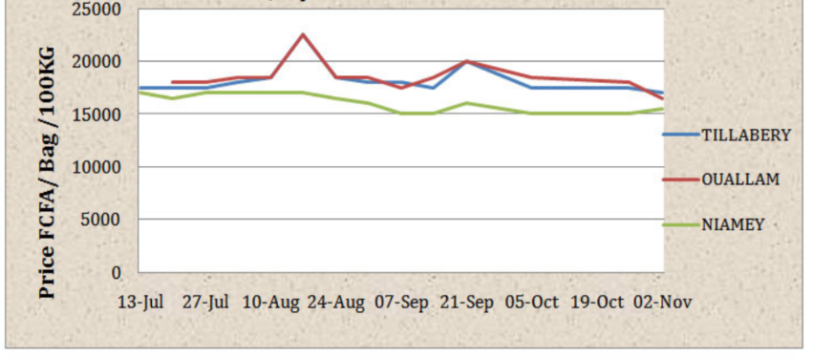
Interpretation: Maize prices increased following voucher distributions in Tillabery and Oullam markets in Niger. They increased again following the second voucher distribution, but to a lesser degree. This may imply that traders were better prepared to meet the higher demand in the second distribution.
Source: CRS. 2012. Impacts of food vouchers on local markets: Reflections from CRS’ experience in Niger. p.11.

- How do commodity prices in intervention markets compare to prices in a comparison market?
Comparing prices in intervention markets to comparison markets can help demonstrate whether price changes in the intervention markets are being experienced elsewhere or are unique to the intervention area.
How to do it: Select a comparison market that closely matches the characteristics of the intervention market you are investigating, and plot the food prices of each to see if the trends are comparable. See Figure 2 for an example. This can help determine whether your intervention is the cause behind price changes in the intervention market.
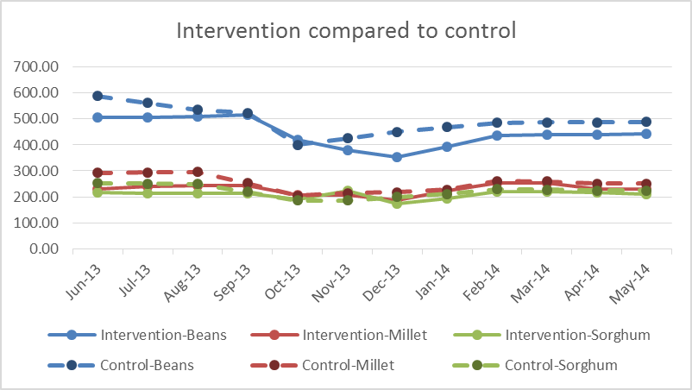
Interpretation: Prices for all 3 commodities follow the same trends in both the intervention and comparison markets. Bean prices fall September to December and then start to rise again in both markets, which is likely due to seasonality and not the intervention. Seasonality should also be investigated to confirm this hypothesis.

