Market Concepts Group Exercise
Instructions: In your group, discuss the following questions around an issue related to market analysis. These are new concepts and it is not expected that you will know all the answers. Feel free to ask for assistance if you are stuck.
You have 30 minutes to discuss within your group. Record your responses on flip charts for presentation to the group. You will then have 5 minutes to lead a discussion on your topic.

Group 3: SEASONALITY
- Explain seasonality in agricultural systems.

- Select a staple crop from your region and draw a sample seasonal calendar. Include on the calendar the rainy season(s), harvest(s), high labor periods and lean season. You can use the below as a template, or represent your information differently.
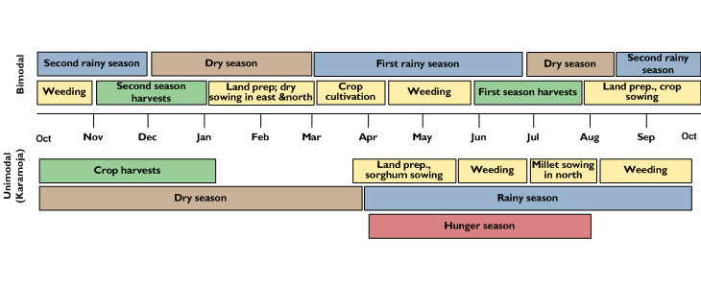

- Below the calendar, illustrate how prices might change over the course of the year.

- How might the following market characteristics change over the course of the year?
  - The number and type of market actors engaged in the market
  - The volume, origin and quality of commodities in the market over the year
  - Consumer demand
  - Roads and infrastructure

- Why is it important to understand seasonality for our programming?

