**Market Concepts Group Exercise: Facilitator Cheatsheet**

**Group 1: MARKET INTEGRATION**

1. What is market integration?

**Market integration - the degree to which market systems in different geographical areas are connected to each other. Markets are integrated when:**

* **Price shocks from one geographic market are transmitted to other markets through the trading of goods**
* **Supply of food adjusts spatially to meet demands**
* **An increase in prices in a market signals traders to bring in more supply, bringing prices back down.**

**If market integration is poor due to weak information and infrastructure and high transport and marketing costs, supply will not flow into the market, increasing prices for the population. In such cases, cash-based programs can have significant effects on local prices.**

1. Consider the following price series for three markets, where Market A is the capital city, and Markets B & C are other markets within the country that have been affected by disaster.



1. Which markets are integrated, and which are not? How can you tell?

**Markets A & B are integrated. Markets A & C are not integrated.**

1. **Similar price trends, with the difference in prices due to marketing costs (transport)**
2. **Markets are not integrated because price peaks in the local market did not act as a signal for more supplies from the capital. During harvests, food is not moving out to bring prices back up.**
3. **Market integration smooths seasonal price fluctuations.**
4. Which factors might explain the differences in the two price series? (i.e. what are some criteria for good and poor integration?)

**Criteria for good integration – good road infrastructure, geographical distances, market information, high number of market actors**

**Criteria for poor integration – high transport costs, insecurity, informal taxes during routes, poor road structure.**

1. Name some ways that market integration might decrease in an emergency.

**Changes in emergency – damage to transport infrastructure, elimination of key market actors who provided links with other markets, lack of finance for trading activities (break down of credit), insecurity and conflict**

1. Why is market integration important for our programming?

**If market is not integrated, increasing demand through cash/vouchers will not signal more supplies, causing prices to increase.**

**Group 2: GOVERNMENT POLICIES**

1. For each policy listed below, please indicate possible impacts on markets and populations. You may not have time to complete all of them. Start with the ones you know, then take your best guess at the others.

**See answers on Handout 4.3.5: FEWS POLICY IMPACTS**

1. Why is it important to understand government policies for our programming?

**Government policies can impact prices and the flow of food in and out of markets. Some policies make the supply and flow of goods less responsive to market signals.**

**Group 3: SEASONALITY**

1. Explain seasonality in agricultural systems.

**Seasonality in agricultural systems refers to seasonal variations in the patterns of production, trade and prices. Seasonality is due to weather patterns, length of maturation of crops, birthing cycles, etc.**

* **Seasonal patterns may reveal themselves through seasonal price fluctuations for inputs and outputs, or seasonal shifts of activity as people move between farming and wage employment.**
* **In agricultural market systems, seasonality results in shifts in demand for labor for ploughing, weeding, harvesting; and a surge in the supply of produce after harvesting.**

1. Select a staple crop from your region and draw a sample seasonal calendar. Include on the calendar the rainy season(s), harvest(s), high labor periods and lean season. You can use the below as a template, or represent your information differently.

|  |  |
| --- | --- |
| |  | | --- | | http://v4.fews.net/docs/timeline/fewsTimeline_ug_en.gif | |

1. Below the calendar, illustrate how prices might change over the course of the year.

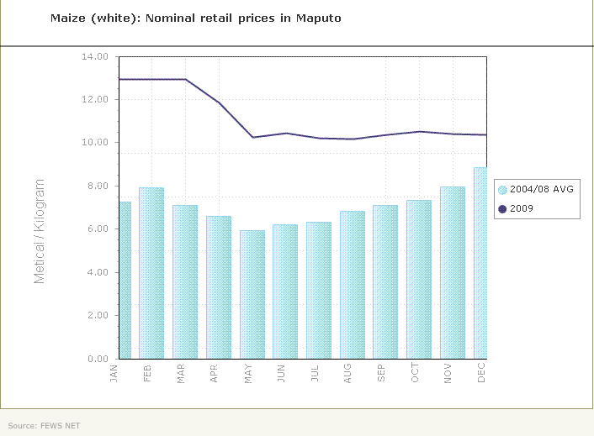

**Note that this graph does not correspond with the seasonal calendar above.**

1. How might the following market characteristics change over the course of the year?
   1. The number and type of market actors engaged in the market

**The number and type of participants engaged in the market may change over the year, e.g. the number of traders and transport services tend to peak around the harvest period.**

* 1. The volume, origin and quality of commodities in the market over the year

**Availability of supplies is usually higher after harvest while supplies are less in the lean season; Local products are more common at harvest time and imported products are more common during the lean season; there may be changes in quality over the course of the year due to moisture levels, perishability, infestations, poor post-harvest practices, etc.**

* 1. Consumer demand

**Demand may be lower in the post-harvest season as households consume their own stocks; demand increases as households become more dependent on market purchases to meet their food needs**

* 1. Roads and infrastructure

**Road infrastructure may become impassable during the rainy season in areas that do not have all-weather roads, or due to inundation/flooding.**

|  |  |
| --- | --- |
| |  | | --- | |  | |

1. Why is it important to understand seasonality for our programming?

* **Changes in price and volumes may not be due to the emergency, but due to predictable seasonal changes.**
* **Need to know how to compare baseline and post-emergency data**
* **Certain programs may work in certain times of the year, but not in others. Interventions needed may be different at different times of the year.**

**Group 4: COMPETITION AND MARKET POWER**

1. What is market competition?

* **Rivalry in the market place.**
* **Exists when buyers and sellers have a real choice between alternative market actors.**

1. What is market power?

**Market power is when a single actor – or small cartel working in collusion – is able to dictate or strongly influence prices in their own favor, thus earning excessive profits.**

1. Describe how negotiations may differ between market actors in the two scenarios below. How might the prices that small-scale producers receive, and consumers pay, differ between the two?

Consumers

**N = 4000**

Small-scale producers

**N = 200**

Traders

**N = 15**

Small-scale producers

**N = 200**

Traders

**N = 2**

Consumers

**N = 4000**

|  |  |
| --- | --- |
| |  | | --- | |  | |

**In the first case, there is a small number of traders. So small-scale producers do not have many options for who to sell to, and consumers do not have options from whom to buy. So the traders in the middle of the chain can set the prices.**

**In the second case, the small-scale producers can get better prices because the traders need to compete with each other to buy their goods. Similarly, the consumers have more choice, so the traders need to provide a good price to get their business.**

1. How might competition decrease in an emergency?

* **Reduced competition – market actors exit**
* **Increased monopolistic behavior – actors start colluding**
* **Greater exclusion – worse restrictions on where and when certain market actors can operate**
* **Greater market distortion – actions by governments (or aid agencies) which temporarily disadvantage vulnerable producers or depress economic activity.**

1. Why is it important to understand market competition and power for our programming?

**If there is not competition in markets, collusion between traders can cause prices to rise (or stay high), even though supplies are available and the market system is otherwise performing well**

1. How might our program design affect market competition/power?

* **Can facilitate the entry of new actors**
* **Can target certain types of traders in our voucher and procurement programs (positive or negative impact)**