Vehicle Maintenance System - The Country Program will establish and monitor a vehicle maintenance system that documents the scheduling of regular inspections and maintenance service for all CRS-registered vehicles in compliance with the manufacturers maintenance requirements. The maintenance history for each vehicle will be maintained in separate files.
Policy: POL-OSD-VEH-001 – Use of CRS Vehicles
Adequate maintenance procedures must be developed to keep the property in good condition.
USG Regulation 2 CRF 200.313.d.4 - Equipment

Regular maintenance and prompt repair of vehicles (referred to generally as “maintenance”) is paramount to ensuring the long-term viability, operational efficiency, and safety of our vehicles and staff. The establishment of a viable maintenance system is also a CRS policy requirement. VMU staff must identify local service providers who run high-quality maintenance facilities and can access genuine spare parts and high-quality consumables (e.g., motor and gear oil), then negotiate terms and sign an agreement with them. In some cases, when quality service and spares providers are absent, CRS will require in-house capabilities to perform regular maintenance, and may retain a small stock of spares and consumables.
The VMU is responsible for tracking ongoing vehicle use and performance, and for scheduling and carrying out regular maintenance of the vehicles according to manufacturer recommendations and specifications. The timing of regular services, according to most manufacturers, is at least every 5,000 km or 3,000 miles. In urban environments and countries with generally good road infrastructure, following the manufacturer’s recommendations is appropriate. However, in many operating environments CRS work in, the road infrastructure is poor to truly appalling, and the impact of travel on our vehicles requires more frequent regular servicing, and minor to fairly significant repairs.
The VMS has various functions that permit VMU staff to monitor maintenance due dates, plan for vehicle down time for maintenance, and to fully document and allocate maintenance activities and their costs. For example:
- the VMS Generate Reports Module (available on the main page of the software) provides a report called “Expected Maintenance Dates” (below) that can be read on-screen or printed out. The VMS calculates the date(s) that vehicles will likely require servicing based on usage trends over a period selected by the user (e.g., last 90 days). This function can be quite valuable for planning purposes;
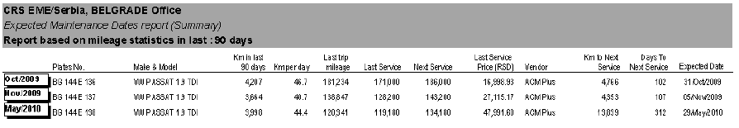
- the VMS Maintenance Module (available on the main page of the software) permits the user to select a vehicle that is due for maintenance, and to then produce a “Work Order” (window shown below) with specific maintenance tasks. The Work Order is then printed out (click “Work Order Report Preview”), approved by an authorized staff, and sent to the maintenance vendor (external or internal) with the vehicle. The VMS stores the Work Order, which can be imported into the vehicle’s Maintenance Report (accessed through the Maintenance Module) upon completion of the work. At that time the VMS user simply enters the costs of parts and labor from the invoice;
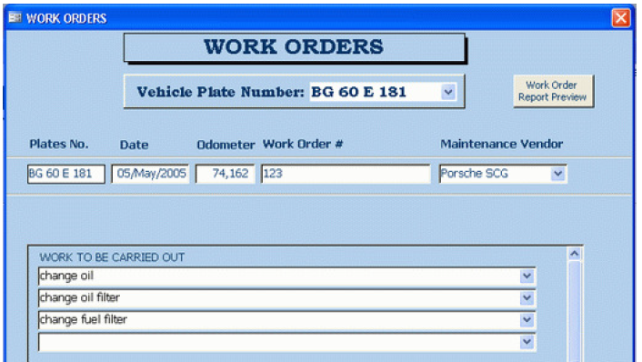
- using the VMS Generate Reports module, the user can access and print out a full maintenance report for any vehicle, over a selected period or on a specific date. An individual Maintenance Cost Sorted by Vehicle report should be printed out (example below) and attached to a photocopy of the completed Work Order, the service provider’s invoice, the Vehicle Handover and Retrieval Checklist, and other related documents for filing in section 4 of the Vehicle Asset File.
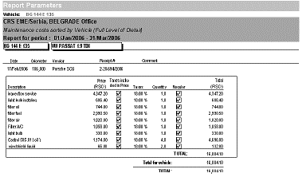
The process for managing maintenance activities are described below. For locations who either aren’t using or don’t have access to the VMS, the use of manual forms (attached above) is explained.
The process is essentially the same for external and internal maintenance activities, with one difference: the procurement of spares, or their dispatch out of our stocks. For guidance on how to request and document the use of CRS spares, refer to section 8.D - Dispatching Spares from CRS Stocks.”
Work Order/Completion Certificate: initiates and documents maintenance activities. The VMU initially fills a Work Order out in the VMS, or completes a manual version (embedded above), in triplicate. It is approved by the HoOps or designate. One copy is retained in the VMU; the original and one copy are sent to the service provider or CRS garage facility. The signed original returns from the service provider to CRS attached to the vendor invoice and other documents.
Complete the form as follows:
  - Date that the form is completed.
  - W/O No.: W/O-AA-yymmdd-## where “AA” is the office code, “yy” is the year, “mm” the month, and “dd” the day of the request, and “##” indicates a number in series for the forms used on the same date (e.g., W/O-BA-150222-03 is Banda Aceh, 22 February 2015, third Work Order of the day).
  - To (Service Provider), or, in the case of CRS garage facility, enter “CRS Garage.”
  - Contact No. is required when the vehicle is sent to a service provider.
  - From (Field Office), enter complete field office name.
  - Contact No. is the cell phone of the Transportation Officer.
  - Equipment ID is the type, year, make and model of the equipment and either its license plate or inventory ID number (e.g., for generators).
  - Odometer Reading for vehicles, and the hour meter reading for generators.
  - DSPN paying for the maintenance and repair.
  - Work to be Done/Problems Identified: can be general (e.g., Regular Service), more specific (e.g., repair and paint front right fender) or unspecific (e.g., check suspension). Try to be as detailed as possible to ensure the CRS or service provider Mechanic understands the limits of approved action.
  - Work completed is checked off and initialed as the approved work is finished.
  - Requested by shall be signed by the staff member initiating the Work Order.
  - Approved by is signed by the Logistics Officer or designate.
  - Additional Approved Work Completed/ Problems Identified allows the service provider or mechanic to inform CRS of additional recommended work and for the Logistics Officer or designate to approve either verbally or in writing.
  - Certified by is an acknowledgement by CRS that the original approved work has been satisfactorily completed.
Vehicle Handover and Retrieval Checklist: documents equipment and other accessories left in or mounted to vehicles that are sent to a maintenance facility. It is filled out in four copies by the VMU, and approved by the Fleet Manager and Driver who takes the vehicle to the facility. One copy is retained in the VMU; the original and two copies are sent to the maintenance facility. Once signed by the facility manager, two copies return to the CRS office. Upon completion of the work, both copies are taken back to the facility when the vehicle is retrieved. The CRS Driver confirms all items are as they were left, signs and give one copy to the facility manager. The original copy returns with the Driver to the VMU.
Complete the form as follows:
  - Country Program: enter the name of the Country in which you are working.
  - VH-RC No.: AA-yymmdd-## where “AA” is the office code, “yy” is the year, “mm” the month, and “dd” the day of the service request, and “##” indicates a number in series for the forms used on the same date (e.g., VH-RC-BA-150222-03 is Banda Aceh, 22 February 2015, third VH-RC of the day).
  - Registration Number of the vehicle being sent out for maintenance.
  - Date the form is completed.
  - Mileage at the time the vehicle is left at the maintenance facility.
  - Fuel Level is approximate at the time the vehicle is left at the maintenance facility.
  - Valuable Items: enter the quantity of each item and indicate any damage. Additional items may be added at the bottom of the list area.
  - Other Items: enter the quantity for each item and indicate any damage. Additional items may be added at the bottom of the list area.
  - Liquid Level: enter information as appropriate.
  - Driver and CRS Fleet Manager Names shall be entered on the computer prior to printing out the form. Both will sign an date the form before taking the vehicle to the maintenance facility.
  - Garage Manager prints his/her name, signs and date the form when the vehicle is released to the maintenance facility.
  - Return Section is completed by the person retrieving the vehicle, acknowledging that all items and fuel is accounted for upon release by the facility to CRS.
Once the work has been completed and the vehicle is retrieved, copies of the completed Work Order/Completion Certificate, Vehicle Handover/Retrieval Checklist, and the Material Request & Issuance Voucher (see section 8.D - Dispatching Spares from CRS Stocks) are left at the facility; the originals of all documents return to the VMU attached, as applicable, to the vendor’s invoice.
The Driver who retrieves the vehicle is responsible for entering the maintenance activity into the Vehicle Log Sheet before departing the maintenance facility.
The VMU reviews, validates and prepares a payment request, attaching the originals of all documents, for HoOps approval. Once approved, the VMU photocopies all documents for the Vehicle Asset File. If using VMS, enter data from the invoice into the VMS using the Maintenance Module, and print out a VMS Maintenance Report as a cover sheet for the document package(s). The original documents are sent to the Finance Office for payment processing. The photocopied document package is placed in section 4 of the Vehicle Asset File.
Equipment Maintenance and Repair Report: is not required if using the VMS to track maintenance activities. If VMS is not being used, this standardized report offers an easy-to-read format for documenting any given maintenance activity for the Vehicle Asset Files and for Finance. The VMU should fill out a form for every maintenance, no matter how minor. The form is essential, and most valuable, for documenting the costs in time and spares for servicing and repair done at the CRS garage, especially when spares are dispatched from CRS stocks.
Complete the form as follows. Attach it as a cover sheet to the WO/WC, VH/RC and other documents as determined by the Fleet Manager. The original documents are sent to Finance; photocopies are placed in section 4 of the Vehicle Asset File.
  - Equipment ID: enter the type, year, make and model of the equipment and either its license plate or inventory ID number.
  - Date of Maintenance or Repair is the date the work started.
  - Odometer/Hour Reading is the KM or reading of the vehicle on the date the work began.
  - Next scheduled maintenance (date / KM / hours) indicates for scheduling purposes the next recommended servicing. It is either a specific date (normally planned for every 3 months) or KM (normally every 3,000 – 5,000 KM for vehicles and 1,500 KM for motorcycles), whichever comes first. In other words, if an equipment reaches its KM before the planned date, it must be serviced. If it reaches the date before the KM reading, consider servicing it. In all cases, avoid letting the equipment exceed its scheduled maximum operating KMs.
  - Petroleum products consumed (oil / other liquids / grease): enter in the appropriate cell the quantity in liters or KG consumed. Other liquids includes consumables like radiator fluid, brake fluid, etc., and shall be detailed in the comments section.
  - Total cost (petroleum products): calculate the total cost of the products consumed (the unit cost should appear on the Inventory – Spare Parts).
  - Parts Replaced / Unit Cost / Other Information allows for the detailing of the cost of the repair (not including petroleum products). The section includes:
    - Work Completed / Parts Used (Describe): enter the work done (e.g., Regular Service) and parts used (part type and/or part number and/or item number).
NOTE: For specific and irregular work the labor and parts data can be entered on the same row (e.g., Replaced injection pump, part # INJ-101015, Item #456).
    - Parts: enter the Unit Cost and Number of Units for each part.
    - Labor: enter the Hourly Labor Rate and Number of Hours it took to complete each type of approved work.
NOTE: If CRS operates the maintenance facility, it is strongly recommended that a standard hourly labor rate be determined and applied to all work completed at the facility for estimating the full costs of maintenance and repair. Normally, this is the gross salary for normal working hours of the national staff Driver/Mechanic and any assistants, with 25% added in to cover other unforeseen costs such as utilities and the depreciation of garage tools and equipment, divided by 176 (i.e., 22 work days x 8 hours per day).
- Total Costs calculate automatically.
- Expenses section calculates automatically.
- Remarks/Notes: enter as appropriate.
- Work completed at (location/vendor): enter the maintenance service provider name or “CRS Garage.”
- CRS Work Order Number: enter the related Vehicle Work Order reference number.
- Vendor invoice number: for work completed outside CRS by a service provider.
- Report prepared by: the name of the staff member.
- Report reviewed and approved by: is signed either digitally or in ink by the Fleet Manager or designate.
- Payment approved initiates a payment of the vendor’s invoice.
- Entered in VMS on (date): the VMS Data Entry Clerk will check the box, and notes the date upon completion of data entry into the VMS Maintenance report for the vehicle.
- Entered into VMS by: the VMS Data Entry Clerk signs.
Once completed electronically, the Report – Equipment Maintenance & Repair should be saved to the computer with a unique filename in a folder entitled “Vehicle Maintenance Reports,” or saved in an electronic file created by the VMU for each vehicle. We recommend using the same number as the Vehicle Work Order that initiated the servicing.

ADDITIONAL TOOLS (embedded above):
Report - Equipment Monthly Operation Expenses: can be used in CPs or operations that are not currently using the VMS. This Report rolls up expenses related to the operation of the fleet (e.g., fuel, lubricants, maintenance and repair) during a specific period, and can facilitate cost allocation. The VMU enters data from various sources to populate the report. Attach photocopies of other reports to it to justify the data, specifically those related to fuel consumption, and maintenance and repair. Send the complete package to Finance, and retain a photocopy of the package in a folio binder created for that purpose.
Vehicle Maintenance Tags: serve as reminders to Drivers and other VMU staff of maintenance due dates. The VMU fills out a tag following each regular maintenance and hangs it (use a rubber band or piece of string) in a visible location inside the cab of the vehicles. Many attach it to the turn signal lever. If using this option, please enter it into the Vehicle Daily Inspection Checklist so looming maintenance deadlines are noticed and the VMU alerted.

