Irrespective of personal or business use, employees found at fault for physical damage to or loss of a vehicle are subject to a deductible not to exceed US $500 per event for the repair or replacement of the vehicle. Deductibles for national staff found liable for damage to or loss of a vehicle are set by the Country Representative in alignment with local legal statutes. Under no circumstances may penalties exceed 25% of one (1) month’s net salary.
Policy: POL-OSD-VEH-001 – Use of CRS Vehicles
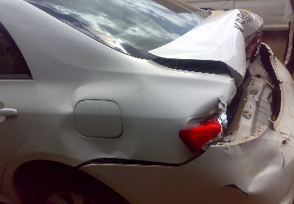 |  | 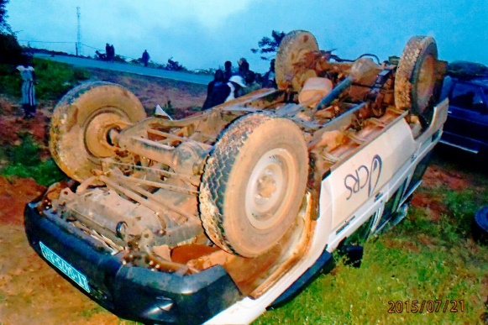
CRS Drivers and Authorized Users are required to report any and all incidents and damage to CRS vehicles, no matter how insignificant they may appear. Depending on the type of incident, different reporting formats are used as described below. Depending on the severity of the incident, further investigation by a senior manager and a determination of guilt may be warranted. Drivers and Users found at fault may face minor to severe sanctions, and financial penalties may be imposed as per CRS policies and as permitted by local law.
When unreported accidents, damage to or loss of a vehicle are discovered, they will be fully investigated and generally deemed to be the fault of the driver. Not reporting accidents is a serious offense which could result in penalties ranging from suspension of driving privileges up to termination of employment.
- Accidents (or “Road Crashes”) are defined as follows, and must be reported on a Vehicle Accident Report Form:
    - any event involving a CRS vehicle that results in injury or death to an employee or 3rd party;
    - material damage resulting from the following categories, regardless of repair cost:
  - collision between moving vehicles (includes non-motorized vehicles);
  - collision between a vehicle (or motorcycle) and a stationary object (e.g., in a parking lot while backing up);
  - non-collision road crash such as a vehicle roll over, spinning out of control, skidding or running off the road;
  - collision with a pedestrian or animal;
  - vehicle damaged while parked.
- Incidents are defined as follows, and must be reported on a Security Incident Report Form:
  - theft of a vehicle;
  - theft of objects from a vehicle;
  - carjacking.

Levels of damage to vehicles are defined as follows:
Level 1 – Negligible: damage considered normal wear and tear (e.g., dent from door of another vehicle caused in a parking lot; surface scratches) that generally does not require immediate repair, and does not impact the operational status of the vehicle – does not result in vehicle down-time. Alert the VMU and/or HoOps. They will decide if a Vehicle Accident Report is necessary.
Level 2 – Minor: damage that is not considered normal wear and tear, and may require repair either to retain the value and appearance of the vehicle (e.g., small dents to a fender; bad scratches that go through the paint to the body of the vehicle) or to bring back to a safe and fully operational status (e.g., broken tail light cover; broken side-view mirror) – may result in a small amount of vehicle down-time. Alert the VMU and/or HoOps. Generally, a Vehicle Accident Report is necessary.
Level 3 – Significant: damage that must be repaired to bring the vehicle back to a safe and fully operational status (e.g., broken windshield or other window; dent that restricts door operation or wheel functionality) – may result in extended vehicle down-time. Alert the VMU, HoOps and/or CR. Complete and submit a Vehicle Accident Report to the HoOps or CR.
Level 4 – Major: damage is so severe the vehicle can no longer be operated safely or legally until repaired – generally results in vehicle being out of service for several weeks. Alert the VMU, HoOps and/or CR. Complete and submit a Vehicle Accident Report to the HoOps or CR.
Level 5 – Totaled: damage to the point the vehicle either cannot be repaired or the costs of repair exceed its residual value. Alert the VMU, HoOps and/or CR. Complete and submit a Vehicle Accident Report to the HoOps or CR.
Whenever a Driver or Approved User is in a road crash while operating a CRS vehicle, they must complete and submit a Vehicle Accident Report to the HoOps within three (3) days. Passengers are also requested to complete an Accident Report Form as witnesses to assist with any investigations. The HoOps, in coordination with the CR, Security Officer and other senior staff, may decide to investigate further, and will make a determination of fault. They will then specify the payment of a deductible as appropriate, and ascertain the status of driving privileges.
The CR or designate must notify the RD and/or DRD-MQ of all road crashes involving resulting in an injury or fatality, vehicle damage at levels 3-5, and serious abuses by Authorized Users. The RD (or designate) in collaboration with the CR (or designate) and perhaps the Regional Security Officer, will decide upon and document a recommended course of action. The decision may be no action whatsoever, it may require the User to take additional driving lessons (internal or external) and repass a driving test, or could result in a probationary period, suspension or removal of driving privileges. Serious abuses will potentially derive more serious punitive measures up to and including loss of employment.
Under no circumstances may a Driver or Authorized User independently contract a service provider to repair damage caused in a road crash in which they were involved. CRS has preferred service providers to which the VMU will deliver the vehicle if it requires repair. Once CRS receives an invoice for the repairs, the person responsible for the damage will be notified of any costs due CRS for the repair.

