All documents related to the purchase of a vehicle must be retained in a permanent file for that vehicle in the Country Program office.
Procedure: PRO-OSD-VEH-003 - Selection and Purchase of CRS Vehicles
Country Programs must establish and maintain an effective property management system. The property management system will include - regular physical counts of equipment, maintenance and repair of equipment, tracking of equipment location changes, documentation of additions or removals from inventory, and documentation of final disposition.
Policy: POL-OSD-PRM-001 - Property Mgmt

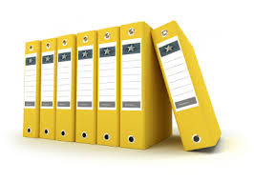 | CRS and donor policies and procedures require reporting on the status and disposition of capital assets annually at a minimum. For internal control and day-to-day management purposes, it is imperative that asset files be created, complete and current. The Vehicle Management Unit (VMU) is responsible for creating and maintaining a complete file for each and every vehicle owned by the CP. Over time of use, a vehicle file will grow and ultimately document the entire life of the vehicle, from initial requisition through final disposition.
Internal Audit highlights recurrent issues with the quality of asset documentation. This results in findings which CPs must respond to after each audit. By keeping vehicle asset files current and orderly, the CP will face fewer audit recommendations, saving time and effort for everyone involved. Setting up and maintaining a compliant vehicle asset filing system is not difficult. The system described below has proven to be simple, effective, and compliant. The HoOps, in coordination with the Fleet Manager, shall designate a VMU staff to set up the system and manage the files.
This section describes the CRS standard process for documenting and maintaining vehicle asset files (it works for motorcycles and generators as well). Documenting and maintaining the vehicle asset files requires VMU staff to collaborate closely with the CP Purchasing and Finance departments.
Basic protocols:
- For each vehicle asset, a separate hard copy file must be kept in a folio binder. Electronic files kept on the server, labeled by License Plate Number and Inventory ID Number, are strongly recommended.
- As a hard-copy file grows, a second folio binder may be required. Label in the same way as the primary file binder, an use it only to store Vehicle Log Sheets.
- Create and print out labels for the folio binders that include at a minimum: the vehicle license plate number; year, make and model; DSPN that procured the vehicle; and CRS inventory ID number. See sample below.
Each file is divided into five (5) sections, from bottom (section 1 – complete procurement file) to top (section 5 – Vehicle Log Sheets) of the binder. Use file separators between each section. Documents in each section should be filed chronologically, from oldest (bottom) to most recent (top).
Documenting the Vehicle Asset File:
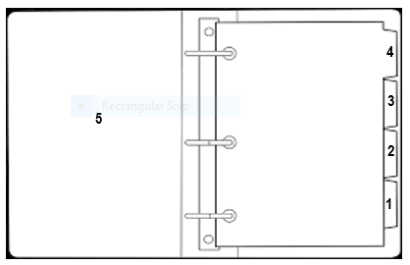
Section 1) Complete procurement file (the procurement process closes when CRS takes delivery of the vehicle) shall include the following documents:
- Purchase Request (PR)  - Request(s) for Quote (RFQ)  - HQ Requisition  - Pro Formas  - Bid Comparison  - Local Purchase Approval  - Local Purchase Order (LPO) or HQ Purchase Order (PO) | - Shipping documents  - Importation documents  - Vendor Invoice  - Tax/duty-free documents  - Certificate of Donation  - Vendor Delivery Note (DN)  - Goods Received Note (GRN)  - Fixed Asset Notices (FANs)
Section 2) Licensing, Registration and Insurance Documents (normally done annually). Photocopy all insurance stickers and other documents prior to affixing them to the vehicle. Original titles or “registration books” must be kept together in a binder kept in the Finance safe or other secure location. A photocopy shall be placed in this section of the vehicle file and another in the glove compartment of the vehicle.
Section 3) Accident and Incident Reports (occur infrequently)
Section 4) Maintenance and Repair reports (occur fairly frequently), and completed Vehicle Daily Inspection Checklists (filed weekly). Cover sheet may be the vehicle’s Maintenance Schedule and Record.
Section 5) Vehicle Log Sheets (very regular – file chronologically as they are received and entered into VMS)
The file’s cover sheet will be the vehicle’s Equipment Registry Form (embedded above). The form serves VMU and other staff as a quick reference guide about everything related to the vehicle’s procurement and registration without having to dig through the file. It also helps with the entry of vehicle-related data into the VMS as well as into the CP master inventory. It is important to have a complete procurement file for the vehicle in order to complete the Equipment Registry Form.
NOTE: a unique Inventory ID Number must be assigned to the vehicle by the staff person who manages the CP’s Master Inventory.
Once a hard-copy vehicle asset file is created, the VMU will enter all of the vehicle data into the VMS (using the “Vehicles” menu) as well as the Disposal and Acquisition Plan.

