OXFAM Bucket

Water storage containers: bucket with lid and faucet (Oxfam Bucket or similar)

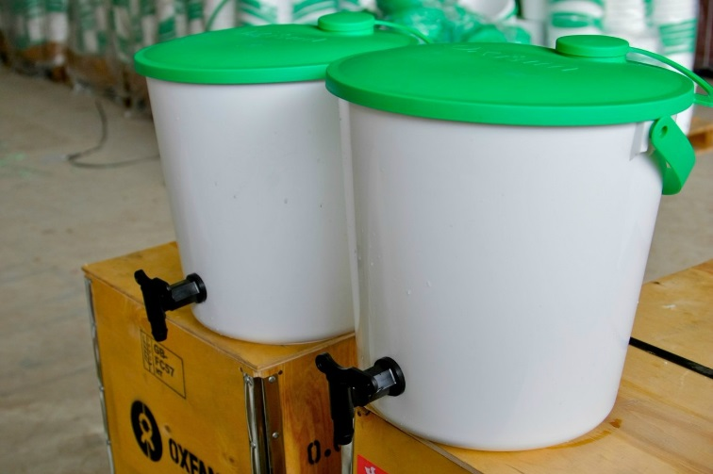
Picture 1: Oxfam Buckets
http://www.oxfam.org.uk/equipment/catalogue/g/water-storage/oxfam-bucket-nrs
http://priyankaindia.com/admin/assets/images/content/post/document/oxfam-bucket.pdf

