Ladle
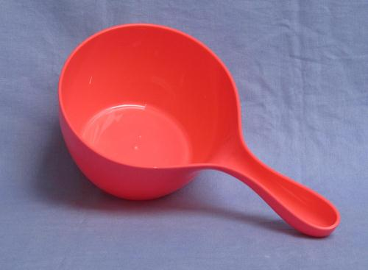

REMARK: Cups for drinking or scooping water from container should never be metallic as chlorinated water reacts with metal (oxidization) and consumes residual chlorine necessary to neutralize bacteria, viruses and other biological contamination

