Aquatabs
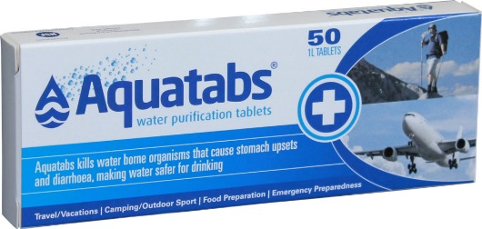
Aquatabs 67mg | For 10 liters of water
Aquatabs 167mg | For 20 liters of water

