**Increasing food security and resilience to shocks throughout the Central Highlands (Bamyan, Afghanistan)**

Donor Agency: EU

Partner(s): Caritas Germany

Background: This programme works on community mobilization for natural resources management (NRM) through formation of local committees. These NRM committees have developed their skills in conducting meetings, planning for some low cost NRM activities (creating role for appropriate use of bushes in pasture land, leadership; community mobilization and conflict resolution related to natural resources management). The NRM committee members have developed skills to conduct meetings, plan for NRM activities, develop pasture land, promote controlled grazing and manage conflicts related to the site selection and controlled use of pasture land by the villagers. In Bamyan province some villages such as Sang-e-surakh, pasture land is located on the border of other villages. This creates tensions with the neighboring villages as their livestock damages the pasture land under development. NRM committee members including women and men hold meetings with their neighboring villagers using this pasture land for grazing and negotiated with them for controlled grazing so that the pasture land under development is not affected. Most households including the committee members have realized the importance of protecting the fodder, not uprooting the whole plant because it improves the soil quality and fodder regeneration.

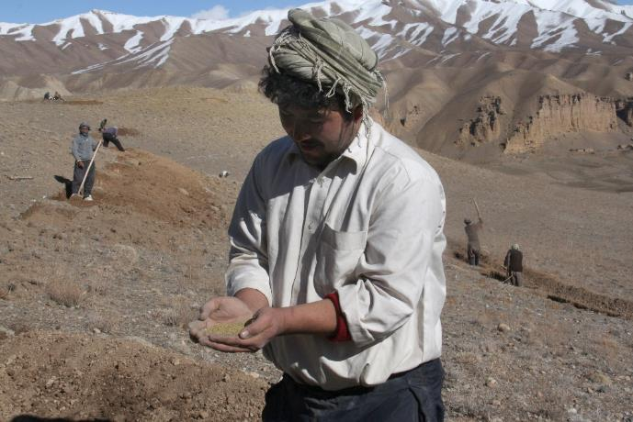

Member of NRM committee sowing Alfalfa seed, (Photo by Nikki, CRS)

**Promoting food security through saving seeds and heritage**

**(Bolivia)**

Partner(s): CENDA

CENDA, works with very vulnerable communities in the Bolivian Altiplano. Bolivian law forbids the selling or barter of local seeds, but the cost of commercial seeds is an economic burden on these communities. In addition, many of the commercial varieties are not appropriate to local climatic conditions. As these are indigenous communities who share a deep commitment to caring for mother earth, their local seed varieties are not only tied to their cosmo-vision but are also to a cultural patrimony. CENDA supports farmers to save, propagate and register these varieties so they are not lost. There are multiple benefits to this: economically farmers have reduced expenses as they don’t have to buy expensive commercial seeds, they also have more resilient and adaptable seed varieties which increases their capacity to cope with climate change.

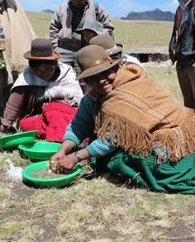

**Green Dignified Jobs**

**(Bolivia)**

Partner(s): UNITAS

UNITAS is a partner in Bolivia who work with refuse collectors living in rubbish dumps in urban areas of the Amazon. These extremely vulnerable people are discriminated against and suffer from great stigma due to their poverty; yet the work they do is critical to society; still they are denied basic rights. The refuse collectors through the support of our partner UNITAS, have been organised into a union and have gained access to pensions, health care and recognised holidays. They are working to formalise recycling arrangements. More than anything, they want to earn dignified livelihoods and be recognised as people who are contributing to their society by caring for the environment through waste management. The case illustrates how dignified green jobs not only support environmental management but also contributes to dignified and sustainable livelihoods for the poorest**.**

**Emergency Livelihood Support and WASH for Affected Populations**

**(Northern Cameroon)**

Partner(s): CODASC

This project targeted populations affected by the Boko Haram crisis in Makary, Kousseri, and surrounding areas in the Logon-et-Chari division, located in the Far North Region of Cameroon.

Among other activities, the project aimed to improve sanitation conditions of the targeted population. A total of 200 household level latrines and 200 showers were to be constructed within this project. At the onset, an environmental assessment was conducted by the program team (both CRS and partner) aiming at identifying the potential threats to the environment.

A similar process to the one proposed by this environmental stewardship tool was followed to first identify the risks and clearly articulate them, then to rank these risks and finally to identify mitigation measures. It was soon made clear that as refugees increased, there was a high risk of deforestation. In order not to add on this existing burden it was decided to limit the quantity of wood to be used in the latrines and showers. By looking into local construction techniques and keeping in mind the need to reduce the quantity of wood being used for construction, it appeared clearly that adobe bricks (uncooked) were the best solution to building the excreta disposal and showers infrastructures.

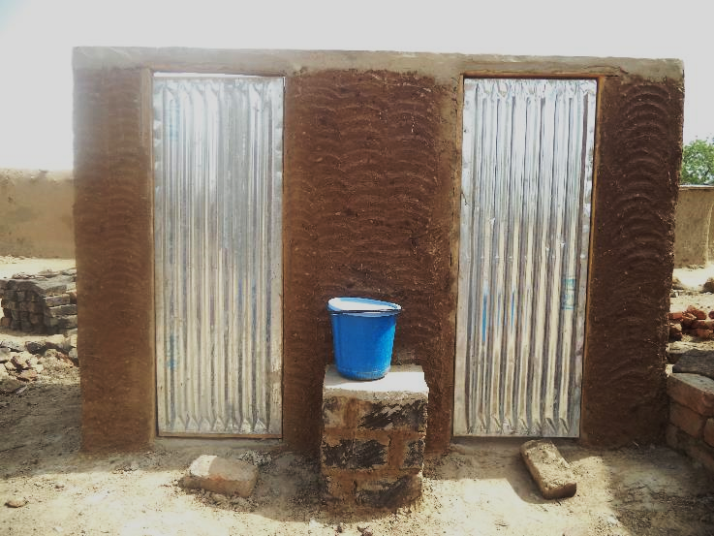

Blocs of latrine provided by the project in Welio, Makary, (Photo: Malama Hichai, CRS)

**Gorkha Recovery and Resilience Program (Gorkha, Nepal)**

Partner(s): System Development Service Center (SDSC)

CRS works to support the Nepal Government Recovery and Rehabilitation efforts from the two earthquakes that devastated the country in 2015, destroying 605,254 houses and damaging 288,244 others. In the Gorkha Recovery and Resilience Programme (GRRP), CRS promotes use of the salvage material from the damaged houses. Households received orientation around the quality of salvage material that can be re-used. This mitigates the risk of high magnitude of un-earthing by the local communities to extract natural resources like stone and timber.

In GRRP, CRS has initiated to build a demo latrine and its septic pit by reusing plastic bottles in one of the program areas. The piloting has been done in association with Center of Alternative Technologies, Wales. The empty bottles are filled and packed with soil-sand composition and will be used to make wall and columns incorporating earthquake resistance elements. The bottles will be 80% of the total building materials used for the whole construction.

Research has shown that the walls built by these bottles are lighter than walls built by using bricks and block, making these building safer in the wake of further earthquakes. Due to the compaction of filling materials in each bottle, resistance of each bottle against the load is 20 times higher compared to brick. Similarly, constructing a house by plastic bottles used for the walls, joist ceiling and concrete column offer us 45% diminution in the final cost.

**Re-use of wastewater as part of Clean House Initiative in rural Nepal**

**(Nepal)**

Partner(s): Parivartan PATRA

In Nepal, Cordaid local partner Parivartan PATRA have been implementing a WASH and livelihoods projects in Rasuwa following the 2015 earthquake., Parivatran PATRA introduced the **clean house concept**, which promotes total sanitation of the individual house and community along with organic vegetable farming, using organic manure as fertilizer and proper waste water management*.* This initiative allows for a closed loop approach – whereby the by-product from one system (for instance the household waste water) could be used as an input for another system, (such as vegetable gardening). As part of the activities, families were oriented on appropriate management of animal sheds including how to store and compost the manure for fertilizer without leaching and evaporative losses. The project set up a wastewater system to supply water to drip irrigation for vegetable gardens. Using wastewater and drip irrigation for vegetable farming has freed up time for women while improving productivity and the family’s nutritional situation. Women no longer needed to spend time to collect water or to buy vegetables in the market, especially during the dry season. The initiative has reduced income spent on food, supported families to use cow manure as compost rather than chemicals, allowed them to diversify their nutritional intake and improved access to water by transforming a waste product into a valuable input.

.

**Strengthening Urban Communities’ Capacity to Ensure Severe Shocks (Philippines)**

Donor Agency: USAID - OFDA

The project worked in 22 at-risk communities in and around Metropolitan Manila to increase community resilience to flooding and other hazards. In addition to using Community Based Disaster Risk Management (CMDRM) techniques such as risk assessment, mapping and contingency planning, the project implemented solid waste management activities to address one of the key challenges related to flooding. 15 communities formulated their own solid waste management (SWM) plans and formed SWM committees that conducted awareness campaigns, behavioral change strategy and promoting SWM livelihoods and enterprises. The project also established Material Recovery Facilities (MRFs) for community members to bring solid waste to process and reuse materials that were clogging drains, canals and other waterways.

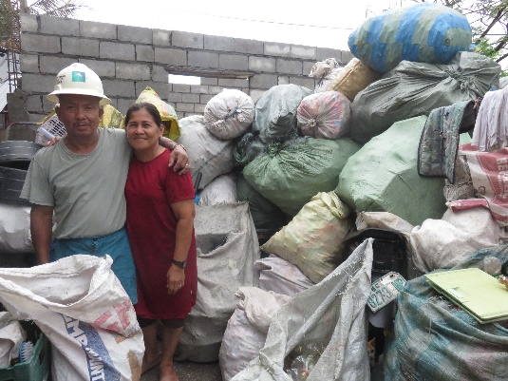

Figure Rosella Valdueza, 68 years old, worked as a Barangay Health worker in BASECO for 14 years. She joined the SWM Livelihoods Program of Project SUCCESS and opened a small junk shop with her husband. (Photo: CRS Philippines)

**Strengthening Resilience to Hazards in Coastal Viet Nam, “Green Shield”**

**(Central Viet Nam)**

Donor Agency: USAID-OFDA

Partners: Government of Viet Nam

The project worked closely with the Government of Vietnam to increase the resilience of disaster-prone central coastal communities to natural hazards, namely through the establishment and management of mangrove plantations to act as buffer zones to tropical storms. In Quang Nam province, in Central Viet Nam, the project worked with three communes to select the most suitable areas for mangrove plantation. Areas were selected based on past events where waves and heavy winds from storms caused extensive damage. The mangroves provide several benefits including slowing down tides, limiting erosion, limit salt intrusion reduce impact of waves during storms and increasing biodiversity. Community committees were established to plant and manage mangroves throughout their development. By the end of the project, government actors and communities had developed a practical, participatory model for natural resource management that was then replicated in other communes throughout the Central Viet Nam.

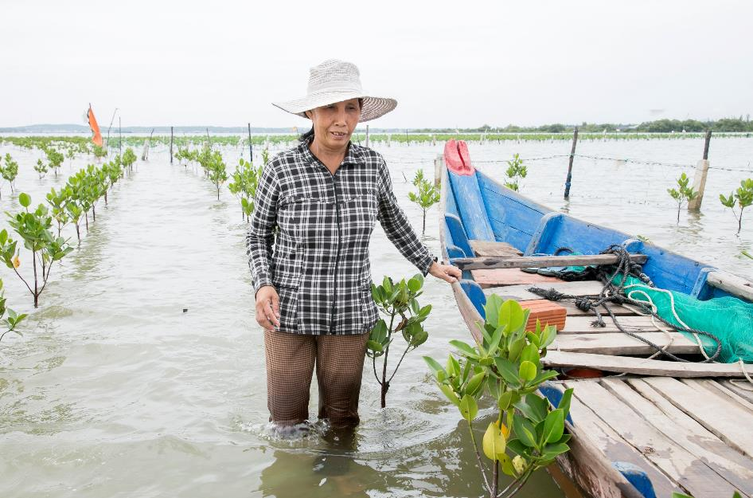

Member of the Mangrove Management committee tends to young mangroves in Central Viet Nam (Photo: Jennifer Hardy, CRS)

.

**Biogas: Converting waste into a resource**

**(Zimbabwe)**

Donor Agency: EU

Partner(s): Caritas Harare and Caritas Mutare

In Zimbabwe, the EU co-funded *Sanitation For Success* programme implemented by *Caritas Mutare* and *Caritas Harare*, environmental care and protection is one of the main focus areas. Technologies such as biogas digesters were adopted. The main objective was to create a cleaner and safer environment with reduced incidence of sanitation and hygiene related diseases such as diarrhoea. Previously, the Murewa mission relied exclusively on massive use of firewood to cook; in order to reduce the use of firewood and as a demonstration site for good waste management practices, the programme constructed a biogas digester. The biogas digester was modified to incorporate sewage from boarding facilities and waste water from the pig sty. The biogas digester reduced the energy cost by an estimated 25% and reduced the number of trees cut down to supply firewood and the amount of smoke emitted into the environment. The programme also installed two 50m3 biogas digesters in Magamba, a high-density residential area, serving at least 2,400 households. The biogas digesters produce around 3m3 of biogas per hr; this is running a 5.5KVA generator used for powering a street tower light to the nearby residents

**Community Managed Water Resources**

**(Zimbabwe)**

Partner(s): Caritas Masvingo

The project aimed to promote sustainable livelihoods and resilience to drought. Farmers in drought prone regions of Zimbabwe rely on rain-red agriculture. Dam (water reservoir) construction was one of the strategies used to compliment rai-fed agriculture and ensure continued on farm production during periods of drought. Prior to project implementation, an Environmental Impact Assessment was conducted to assess and ensure environmental stewardship in the project design and implementation so as to: 1) Maintain the long-term ability of natural resources in the dam catchment to support human, plant and animal life; 2) Conserve a broad diversity of plants, animals and ecosystems; and the natural processes that they depend upon; 3) Conserve the social, historical and cultural values of people and their communities; 4) Ensured both upstream and downstream environmental implications of the new dam construction. During implementation of the project, one of the community requests was to integrate livelihood activities around the dam catchment so as for the community to release additional benefit of conserving the environment around the dam. Apiculture and fisheries were integrated, leading to community conserving the dam catchment and ensuring quality of the water, thus protecting the dam from erosion and pollution. This initiative was supported by the local government authorities

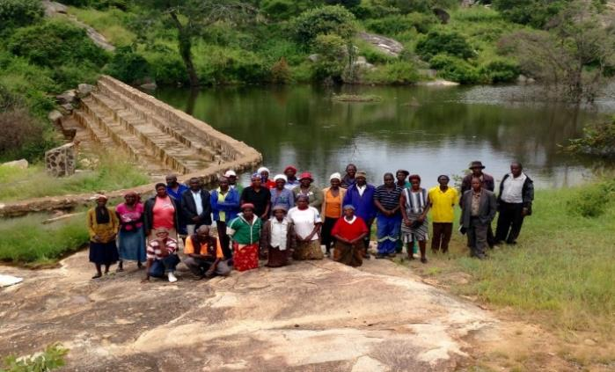

*Water Committee members pause in front of the completed dam which has fish and well conserved trees around the dam have beehives.*