Guidance Document: Cash and Voucher Assistance Feasibility Checklist

Purpose of document:
The guidance below was developed to support CRS country programs and partners to 1) identify the factors to consider in assessing Cash and Voucher Assistance (CVA) programming feasibility; and 2) facilitate decision-making to include cash-based interventions as a viable response option in emergency and recovery operations.

The CVA Feasibility Checklist was developed by the American Red Cross and is part of the IFRC/ICRC Cash in Emergencies Toolkit (http://www.rcmcash.org). CRS adapted the tool to ensure alignment with internal CRS processes and relevance to the Caritas network. The CVA Feasibility Checklist presents all the criteria to consider when deciding to implement a cash and/or voucher assistance program in emergency and response contexts. The design of the checklist was purposefully simplified, with the intention of enabling field teams with limited Cash and Voucher Assistance programming experience to quickly come to a decision around the feasibility of cash-based interventions, meanwhile helping to identify barriers to CVA programs.

The CVA Feasibility Decision Tree is included at the end of this document that supports users to practically respond to the feasibility key considerations and advance through the decision-making process to determine if CVA is a feasible programmatic option. The decision tree complements the CVA Feasibility Checklist and provides a visualization that facilitates the go/no-go decision for feasibility of CVA programming.

This guidance gives an overview of the factors to consider in CVA feasibility assessments, establishes the tool’s methodology, and defines the process for assessing the viability of a cash-based response.

Tool Methodology:
The Cash Feasibility Checklist notes nine criteria that are required for the implementation of a high-quality, at-scale and timely cash-based intervention.
Fig 1: Criteria for Assessing Cash and Voucher Assistance (CVA) Feasibility
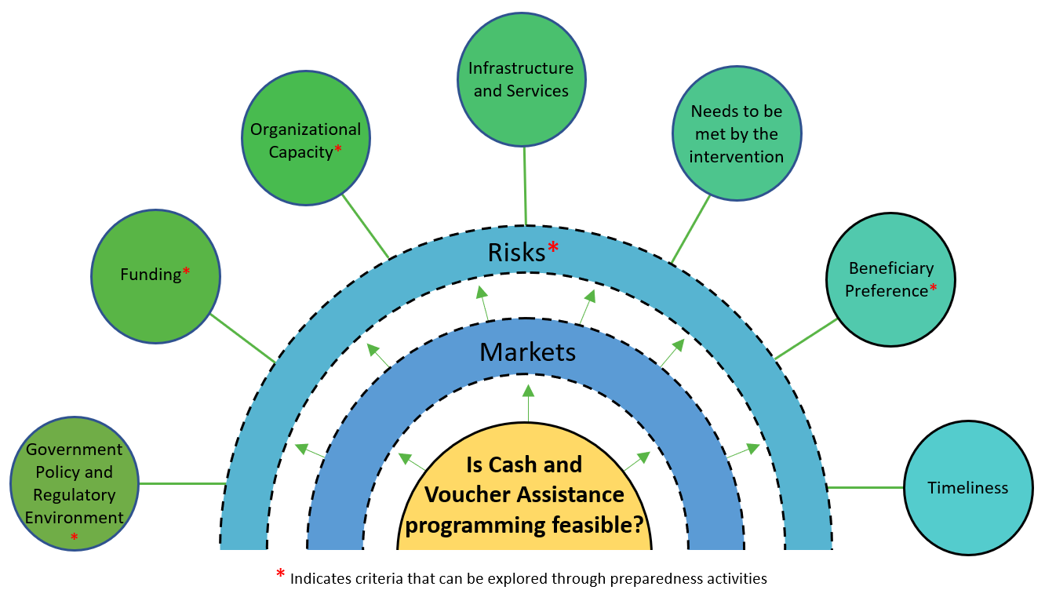
Markets and Risks are essential criteria in determining the feasibility of CVA programs in emergency and response contexts, as their existing conditions cannot be influenced in the short-term by program interventions. In other words, response design cannot affect existing market conditions or potential security or protection risks posed to target groups. As fixed aspects of the greater context, Markets and Risks must be holistically considered in assessing CVA feasibility. If the target market and possible risks are not critically considered, the possibility of doing harm to target and non-target populations is increased and the overall success of the project may be jeopardized.

The CVA Feasibility Checklist provides standardized Yes/No Key Consideration questions for each criteria. To determine the answer to each Key Consideration question, field teams must develop and answer a set of sub-questions that appropriately address the focus of that Key Consideration question. To help reach conclusions for each Key Consideration question, sub-questions can be structured to seek Yes/No answers. Further assessments will often be required to determine the sub-question responses. This document provides an explanation of each criteria and key consideration, along with examples of sub-questions. There are scenarios that cannot be answered simply with Yes/No, but instead require “if X, Y, and Z, then yes” type considerations. These mitigating factors, or factors that allow criteria standards to be met through targeted actions, enable CVA to be feasible under adapted circumstances or at different times within a response.

Some information on criteria marked on Figure 1 with a red asterisk (*) can be gathered as a preparedness activity before a crisis. Preparedness activities will make the go/no go decision process on CVA more efficient and ultimately speed up the response time.

Proposed Audience:
This guidance is designed for new practitioners of Cash and Voucher Assistance programming, as well as for experienced CVA program implementers who benefit from a refresher on factors to consider prior to the implementation of a CVA response. CVA program implementers may decide to skip certain feasibility criteria, based on their level of knowledge and experience in cash-based responses. When skipping feasibility criteria, the guidance authors recommend users to justify their decisions in their CVA Feasibility Report.

CHECKLIST - IS CVA FEASIBLE?
CRITERIA | KEY CONSIDERATIONS | YES | NO | COMMENTS/ POSSIBLE MITIGATION MEASURES
MARKET  [Essential] | Is the economy monetized?
 | Does the population usually use markets to access its needs?
 | Are markets accessible after the emergency?
 | Are needed items available in enough quantity and at acceptable prices in the local markets?
Are traders able and willing to adapt to an increased demand?
Consider transportation, stocking, quality and quantity issues.
 | Are prices likely to remain stable in the coming weeks/months?
RISKS*  [Essential] | Are the risks associated with CVA acceptable or possible to mitigate?  Consider beneficiary and staff security, as well corruption issues.
GOVERNMENT POLICIES AND REGULATORY ENVIRONMENT* | Is CVA in accordance with national and local government policies?  Ensure that there is no prohibition.
FUNDING* | Is CVA within donors’ funding policies and framework?
ORGANIZATIONAL CAPACITY* | Does the agency have the internal capacity (programmatic, financial, logistic) to implement a CVA intervention?  Consider previous experience and potential partnerships.
INFRASTRUCTURE AND SERVICES | Are the infrastructure and services needed to transfer cash to beneficiaries available?  Consider financial and technology requirements (banks, microfinance institutions, mobile phone coverage, etc.).
NEEDS TO BE MET BY INTERVENTION | Can the needs be met through specific commodities and/or services?
BENEFICIARY PREFERENCES* | Is CVA a preferred option for the beneficiaries?  Consider empowerment, dignity issues and beneficiary capacity to deal with technology (mobiles, cards, etc.).
TIMELINESS | Is it possible to set up and implement a CVA with the necessary speed and at the intended scale?  Consider the time that might be required to roll out the different delivery mechanisms.
If all questions have been answered affirmatively, then CVA is a feasible response option.

Criteria 1: MARKETS
The market capacity is essential for determining the feasibility of cash and voucher assistance programs. Without a functioning market, cash and voucher programming is not possible. However, markets tend to recover and adapt quickly following a shock, so the market situation should be regularly re-assessed to revisit programming feasibility decisions. The term ‘Market’ is not limited to a specific location, rather, it is defined as a virtual or physical place that facilitates transactions between parties and actors for goods and/or services. Cash in emergency interventions are primarily directed at supporting families to buy food and non-food items from local vendors, traders and producers. Due to this, the market-related key considerations listed below gauge the capacity and function of the local market in the affected area and/or intervention area. Below are the specific factors to consider when gauging the functionality of a market in relation to a CVA program.
- Key Consideration 1: Is the economy monetized?
Most economies are monetized; however, emergency situations may reduce access to cash for vulnerable communities. This key consideration requires field teams to confirm the monetization of a local economy.
Example Sub-Questions: Do people pay for goods and services using money? Where do people get cash before and/or during the emergency?

- Key Consideration 2: Does the population usually use markets to access its needs?
Communities that are marginalized or cut-off may not traditionally travel to markets to purchase goods and/or services to meet their basic needs. This key consideration requires field teams to confirm that the target population traditionally/typically travels to markets for their needs.
Example Sub-Questions: How often do members of the target population travel to a market to meet their basic needs? What markets do the target population travel to traditionally for their basic needs? How long does it take for the target population to reach the local market? What type of items/goods/services do people traditionally access in the local market?

- Key Consideration 3: Are markets accessible after the emergency?
Barriers to accessing markets may be physical (e.g. distance, security, transportation availability etc.), financial (e.g. due to cost of transportation), and cultural/ethnic (e.g. due to gender, ethnicity). This key consideration requires field teams to confirm that all target communities and groups can access functioning markets; defining access as being able to physically reach markets and transact with traders, vendors and producers.
Example Sub-Questions: What barriers exist for target community members to transact at functioning markets? Can the barriers be resolved to ensure that target communities are able to purchase goods and/or services to meet their urgent needs? Are there specific groups who will struggle to access markets? Can these challenges be addressed? How has the emergency reduced market accessibility for target populations?

- Key Consideration 4: Are preferred items available in enough quantity and at acceptable prices in the local markets?
Limited supply of commonly purchased items in local markets may lead a cash program to create price inflation, do harm to non-beneficiary households, and prevent beneficiaries from accessing the goods/services they need with cash provided. A market assessment is required for any at-scale humanitarian programming type, to avoid price inflation from increased demand. This key consideration requires field teams to assess the availability of key items most needed by the target group, ensuring enough quantity at appropriate prices are available in the local market.
Example Sub-Questions: Are commonly purchased items presently available in the local market? Are prices acceptable for target populations? How have prices changed over time? If items are not available, why? Can vendors/traders source commonly purchase items even if not currently available?

- Key Consideration 5: Are traders able and willing to adapt to an increased demand?
It is essential to measure the local traders’ capacity to meet an increased consumer demand of key items. To avoid a supply-side limitation on goods/services, discussions with traders and vendors are required prior to any humanitarian assistance program. This key consideration requires field teams to assess the traders’ capacity to supply key items, ensuring that traders, vendors and producers can continue resupplying stocks of commodities.
Example Sub-Questions: How long does it take for vendors to resupply their stocks of key items? How frequently are they resupplying their stocks of key items? Do vendors have the capacity to meet the needs of the target population with key items? Would vendors face challenges in increasing their stocks/supplies? If yes, what challenges and how could these be mitigated? If there are disruptions to vendor supply chains after the emergency, can they be addressed and in what timeframe?

- Key Consideration 6: Are prices likely to remain stable in the coming weeks/months?
Understanding price fluctuations by way of a price baseline of key items is ideal. Every cash program should include a price monitoring activity to ensure the cash transfer amount continues to be relevant and appropriate to cover the proposed needs, as well as avoid price increases caused by the cash program. This key consideration requires field teams to log and understand price fluctuations and their causes, such as seasonal changes, through the collection of price data of key commodities.
Example Sub-Questions: What are the expected seasonal changes in prices and their causes? What are the prices of key items and how do they change (expected increases/decreases) over the calendar year?

Criteria 2: RISKS*
Various types of risks, be they institutional, programmatic or contextual, are considered essential for the feasibility of cash programs. All humanitarian assistance programs should consider the different types of risks associated with their intervention, and the mitigation measure to be taken (Avoid, Accept, Control, Transfer).
- Key Consideration: Are the risks associated with CVA acceptable or possible to mitigate?
Cash programming is not feasible when significant risks specific to CVA exist without an identified and appropriate mitigation measure. A risk analysis identifies risks, gauges impact and probability, and defines specific mitigation measures for each risk. Risk analysis should include risks related to 1) safety and dignity of target and other groups; 2) humanitarian access to crisis-affected populations; 3) crisis-affected populations’ access to aid; 4) data protection and beneficiary privacy; 5) individuals with specific needs or risks; 6) social relations – household and community dynamics; 7) fraud and diversion; and 8) market impact. The goal of the risk analysis is not to eliminate every risk, but to identify the most significant risks and establish mitigation measures for them. This key consideration requires field teams to carry out a risk analysis to identify potential moderate to high risks associated with proposed cash-based interventions. Once risks are identified, specific mitigation measures can be defined.
Example Sub-Questions: What are the main risks associated with potential CVA interventions in target locations? Does the agency have control mechanisms in place to monitor and control risks of fraud in CVA? What are the security risks for staff, beneficiaries, and partners associated to the provision of cash in target locations; and how are these risks mitigated/managed?

Criteria 3: GOVERNMENT POLICIES AND REGULATORY ENVIRONMENT*
Dependent on its capacity, governments may or may not have policies or positions regarding the distribution of humanitarian assistance, and more specifically on cash and voucher programming. The feasibility of CVA programs at times can be restricted or promoted by government actors, either through formal written policy or more informal positions expressed through interactions with agencies or in providing permissions or authorizations for specific interventions.
- Key Consideration: Is CVA in accordance with national and local government policies?
Collaboration must take place with local, regional and national governments during the response option analysis and design of cash programs to ensure that the proposed actions are in line with government policies and positions. This collaboration can also provide relationship-building opportunities with government stakeholders in cases where they are unfamiliar or skeptical of CVA. Consulting with other humanitarian actors and the Cash Working Group (if active) regarding cash programs and related government authorizations might also be helpful, as well as consulting financial authorities, such as the central bank. A significant amount of information is likely available online or through a basic desk review. This key consideration requires field teams to consult government representatives and identify any barriers from the government’s side to implement a cash program.
Example Sub-Questions: Is the government (local, regional or national level), using cash or voucher assistance in any of their programs? What, if any, are the concerns presented by government representatives regarding cash programs in emergencies? How can these concerns be mitigated? What are the laws affecting cash and voucher assistance programs, and different payment mechanisms to deliver cash to beneficiaries (e.g. currency of distribution, Know Your Customer (KYC) requirements for beneficiaries, transaction limits, sanctions etc.)? What process do government authorities require, if any, to grant permission to humanitarian actors to implement cash programs?

Criteria 4: FUNDING*
All humanitarian assistance programs are dependent on available funding to implement, and donors may have a specific position on cash programming at the global level and in a specific emergency context. For CVA programming to be feasible, donors must be willing to finance the intervention.
- Key Consideration: Is CVA within donors’ funding policies and framework?
Donors typically have established policies or response frameworks on which intervention strategies are approved for financing, which includes cash and voucher assistance programs. At times, response agencies have their own funding to implement cash programs. Consulting grant agreements, publicly available policies and guidance documents on cash programming from relevant donors, and meeting with donors in country can all help to understand the funding environment and appetite for funding cash-based interventions, including specific conditions. This key consideration requires field teams to ensure funding sources are willing to finance the proposed cash intervention for the length of the response, as well as maintaining compliance with any specific donor policies or requirements
Example Sub-Questions: What are the potential funding sources for cash-based interventions? Do these donors traditionally support cash-based interventions? Do these donors have any specific policies or requirements when designing and implementing cash-based interventions? If so, what are they?

Criteria 5: ORGANIZATIONAL CAPACITY*
The organization’s internal operational capacity is directly related to the scale of the proposed cash distribution. CVA feasibility is dependent on the size of the cash program and the organization’s capacity to set-up, implement and monitor a quality cash program.
- Key Consideration: Does the agency have the internal capacity (programmatic, financial, logistic) to implement a CVA intervention?
Small-scale (e.g. fewer than 200 households) interventions require a lower level of organizational capacity than a larger-scale (e.g. more than 1,000 households) program. The operational capacity of an organization is dependent on relevant staff’s CVA experience; established and tested operating procedures; and the agency’s financial liquidity. In-depth CVA-specific operational capacity assessments can be conducted prior to an emergency (e.g. preparedness), however, during a crisis there may only be time for a rapid assessment to quickly determine if CVA is feasible. This key consideration requires field teams to assess the operational capacity of the implementing agency related to the size and scale of the intervention.
Example Sub-Questions: What experience do key programs, operations and leadership staff have with cash-based programs? To what extent are standard operating procedures in place for the expected scale of distribution and reconciliation of cash-based programs? To what extent are agency cash reserves able to finance an operation prior to donor reimbursements? What gaps in capacity must be filled to make CVA a more feasible response option? Can surge support be mobilized to address any noted capacity gaps?

Criteria 6: INFRASTRUCTURE AND SERVICES
Cash-based programs require the use of traditional financial systems, such as a mobile money system, a remittance network, financial service providers like traditional banks, or a country’s central bank for the printing of fiat currency. This includes voucher-based systems as well. The feasibility of cash-based programs is dependent on the available and accessible financial systems, including infrastructure and/or services to transfer cash safely and efficiently to beneficiary households.
- Key Consideration: Are the infrastructure and services needed to transfer cash to beneficiaries available?
Humanitarian agencies require infrastructure and services to distribute cash and voucher assistance. The delivery mechanisms available to distribute cash assistance are limited by the types of financial systems that are operational in each context. CVA programs rely on some type of financial service provider; however, voucher programs rely primarily on the capacity of the organization and the vendors participating in the voucher intervention. This key consideration requires field staff to gauge the capacity and quality of the available infrastructure and services to support a cash-based intervention.
Example Sub-Questions: What cash and voucher delivery mechanisms are available and operational? Which of these delivery mechanisms can be implemented in the target location? What are the potential challenges related to implementation of these delivery mechanisms (e.g. coverage/presence of agents/offices, network connectivity, liquidity, accessibility by target groups etc.)? How can these challenges be overcome, and/or what alternative delivery options could be used instead?

Criteria 7: NEEDS TO BE MET BY INTERVENTION
The objectives of humanitarian responses are directed to meet specific unmet needs. In most cases, cash-based interventions offer the dignity of choice to beneficiaries, responding to diverse needs and empowering recipients. However, prior to any assistance distribution, a needs assessment is necessary to ensure that the assistance to be provided will be appropriate and aligned to meet specific community needs.
- Key Consideration: Can the needs be met through specific commodities and/or services?
Needs assessments inform humanitarian response designs. Prior to designing a cash-based program, field teams must ensure that the target communities’ urgent needs are for specific commodities and/or services that are available and accessible. This key consideration requires field staff to assess the urgent needs of the target population; can those needs can be met through the procurement of commodities and/or services; and can those commodities and/or services be provided with the necessary quality and safety required for the target population.
Example Sub-Questions: What are the priority urgent needs of the target community? Which of these needs can be met through commodities and/or services available in locally accessible markets? If needs can be met through local markets, how can quality/safe use practices of commodities and/or services be guaranteed?

Criteria 8: BENEFICIARY PREFERENCES*
Response analysis takes into consideration the appropriateness of an intervention, and to what extent the proposed intervention aligns with beneficiary preference. Consulting with the affected population on their preferences for how they would like to receive assistance is a critical component of decision-making for any humanitarian assistance modality.
- Key Consideration: Is CVA a preferred option for the beneficiaries?
When considering response options, humanitarian actors must measure to what extent cash and voucher assistance is a preferred option by the beneficiary. Cultural and social norms, travel restrictions, and other factors may influence the appropriateness and feasibility of a CVA program. This key consideration requires field staff to gauge the preference of the beneficiary around the types of assistance.
Example Sub-Questions: Does the target population have experience receiving humanitarian assistance and/or cash or voucher assistance? If applicable, how does the government disburse social assistance to vulnerable families? What cultural/gender norms and social/household dynamics or other factors influence the acceptance of CVA? What are the reasons for preferences expressed by the target community? If concerns are expressed, can these be effectively addressed?

Criteria 9: TIMELINESS
At times, humanitarian interventions require an immediate response, which leads agencies to count on established practices and systems to distribute assistance. Without prior preparation or readiness capacity, agencies may be limited in the types of interventions they can implement. When comparing response options in the immediate aftermath of an emergency, it is critical that the timeliness of a modality be considered, be it CVA or in-kind. If a CVA response is not the quickest response option immediately following a disaster, then consider when CVA could be implemented.
- Key Consideration: Is it possible to set up and implement a CVA with the necessary speed and at the intended scale?
Urgent needs of the beneficiary population cannot be placed on hold for agencies to build up capacity to respond. CVA feasibility must consider the scale of the response and the time needed to build up capacity of the agency to respond at the appropriate scale. This key consideration requires field staff to balance the level of need with the capacity of the agency to implement a cash-based response, at the appropriate scale and the necessary speed.
Example Sub-Questions: How much time is required to set-up a CVA program? Can beneficiary needs be effectively met in the meantime? What are the timelines for approvals around setting up and implementing cash programs (and other modalities) for the proposed scale and budget amounts?

CVA Feasibility Decision Tree
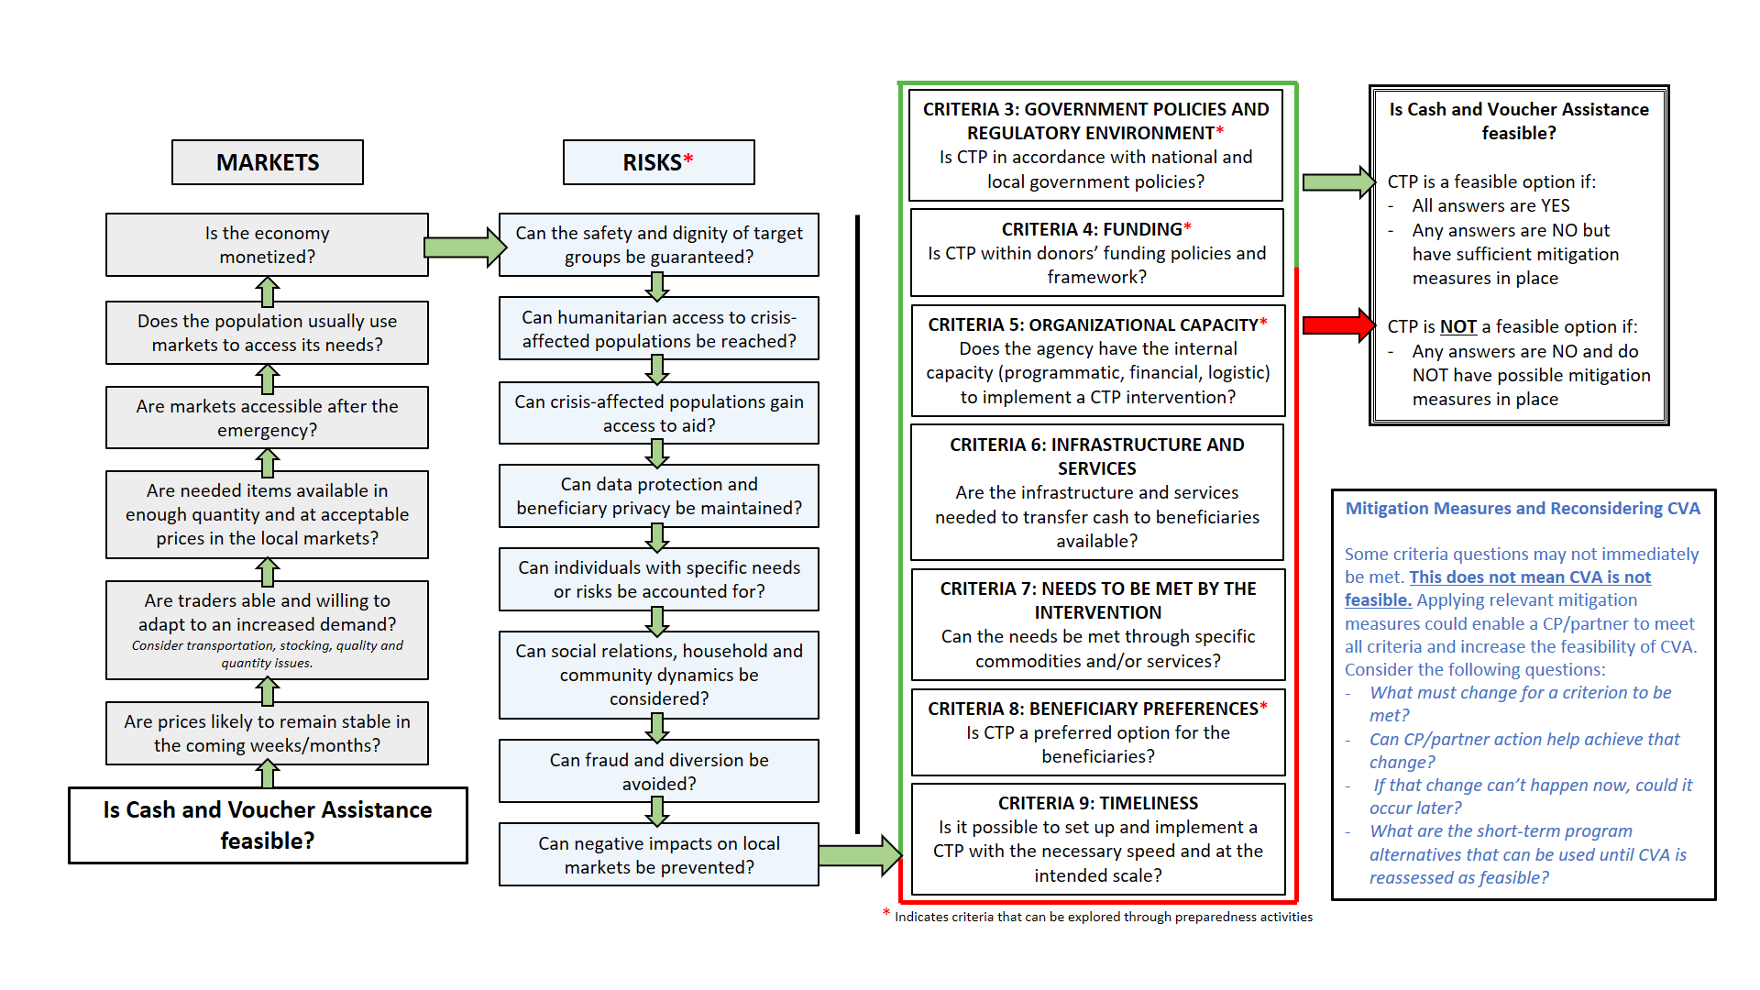

Other assessment types include Multi-sectoral, Beneficiary Needs, Markets, Risks, FSP, and Delivery Mechanisms
Provide example of CVA feasibility report
TOOL: Market Assessment tool; details how often assessments should happen, as well as how to find the answers to other Key considerations in this section
CaLP Glossary: http://www.cashlearning.org/resources/glossary
A monetized economy is characterized as the use of money as a medium of exchange and store of value. Oppositely, a barter economy is cashless, or a non-monetized economic system whereby services/goods are traded at negotiated rates.
Tool for regular price monitoring (e.g. Markit), and general market assessment tools
Other organizations or the Cash Working Group may already have market price data available for key items.
The term “significant risk” is defined based on risk assessment results. Standard risk calculations use the impact x likelihood of a risk to determine how to prioritize and attempt to mitigate each one. Senior managers and/or technical advisors should be consulted through the risk review and mitigation process.
Operational Toolkit for Multi-Purpose Cash Grants: http://www.cashlearning.org/mpg-toolkit/, and Protection Risk and Benefit Analysis Tool: http://www.cashlearning.org/downloads/erc-protection-risks-and-benefits-analysis-tool-web.pdf
The EFOM includes specific examples for risk assessments when planning programme interventions: https://efom.crs.org/efpm/emergency-field-programming-manual/market-based/mbrrr-project-design/risk-assessment/
Examples of governments using cash transfers include Social Safety Net (SSN) and pension programs, emergency support for communities affected by disasters, and enterprise grants, among others.
TOOL: Link to HARC as a more in-depth option
Financial liquidity, or the availability of cash, is most relevant when considering actions with national organizations that do not have large cash reserves.
Fiat currency’ is a common type of currency issued by official order, and whose value is based on the issuing authority's guarantee to pay the stated (face) amount on demand. CaLP Glossary: http://www.cashlearning.org/resources/glossary
TOOL: Needs assessment tool

