Battery wiring diagrams

The following diagrams illustrate how to get increased current (more power) by using parallel wiring and how to increase voltage levels by using series wiring. You can do both using series and parallel wiring in combinations.
Use parallel wiring to increase current (power).
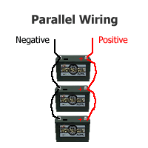 | This diagram shows a simple parallel circuit to increase current or power. Assume that we are using 12 volt batteries. The power of all 3 batteries add to give us the effect of a battery 3 times as powerful but the voltage stays the same at 12 volts. Parallel wiring increases current but the voltage does not change. This is the wiring used when jump starting a car for example.
Use series wiring to increase voltage
This diagram shows a simple series circuit to increase the battery voltage level. Assume that we are using really big 4 volt industrial batteries.
The voltage of all 3 batteries add to give us the effect of a battery 3 times the voltage or in this case a very large 12 volt battery. In this circuit the current is the same as the current in just 1 of the batteries. But since the 4 volt industrial batteries are very large, we have in effect created a huge 12 volt battery. | 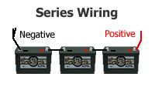
Use series & parallel wiring in combination
This diagram shows a combination series and parallel circuit to increase both the battery current and voltage level at the same time. Assume this time we are using 12 volt batteries.
The left to right series connection add the two 12 volt batteries to make 24 volts. And, since we did this 3 times and then connected each group of 2 (now 24 volts) in parallel we end up with one very large 24 volt battery. It has twice the voltage of a single 12 volt battery and 3 times the current or power because all 3 groups are wired in parallel. | 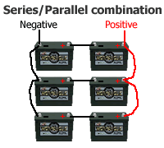
The sky's the limit
So, using series wiring, you can build up the voltage to the level you need and using parallel wiring you can increase the current or power. For example, you could setup a 24 volt battery bank by connecting two 12 batteries together in series or create a 48 volt battery bank by connecting four 12 volt batteries in series. Then just repeat this until you get the power you want and put all those now 24 or 48 volt groups in parallel. Batteries for solar power systems are available in 2, 4, 6, and 12 volts, so any combination of voltage and power is possible.

